

XML SCHEMA DOCUMENTATION



Table of Contents
1. Summary 4
2. Conventions used in this document 4
3. Description of XML Nodes 5
3.1.1 Node “report” 5
3.2.1 Node transaction 9
3.2.2 Transaction Additional Info Type 12
3.3 Node Activity 14
3.4.1 Node t_from_my_client 15
3.4.2 Node t_from 16
3.5.1 Node t_to_my_client 18
3.5.2 Node t_to 20
3.6.1 Node t_party 21
3.7 Subnode goods_services 23
4. Description Of Common Types Used in the Schema 25
4.1.1 Type t_account_my_client/t_account 25
4.1.2 Type Signatory 30
4.1.3 Type Account Related Persons 31
4.1.4 Type Account Related Accounts 31
4.1.5 Type Account Related Entity 32
4.1.6 Type Account Funds 32
4.2.1 Type t_entity_my_client/t_entity 33
4.2.2 Type Entity Related Persons 38
4.2.3 Type Entity Related Entities 38
4.2.4 Entity Identifications 39
4.3.1 Type t_person_my_client/t_person 40
4.3.2 Type
Names 46
4.3.3 Type Social Account 47
4.3.4 Type Employment History 47
4.3.5 Type t_person_identification 49
4.3.6 Type PEPS 50
4.3.7 Type Person Related Persons 50
4.4.1 Type t_person_registration_in_report 51
4.4.2 Type t_conductor/t_conductor_my_client 51
4.5 Type t_address 52
4.6 Type t_phone 54
4.7 Type t_foreign_currency 55
4.8 Type report_party_type 56
4.9.1 Network Device Type 57
4.9.2 IP Address Type 58
4.10 Relation Date Range Type 59
4.11 Comments Type 60
4.12 Business Relationship 60
4.13 Additional Information 61
4.14 Sanctions Node 62
4.15 Means of Transportation Node 63
5. Lookup Values 65
5.1 Submission type 65
5.2 Funds type 65
5.3 Account type 66
5.4 Account status type 66
5.5 Identifier type 67
5.6 Conduction Type 67
5.7 Transaction Item Status 67
5.8 Report Code 68
5.9 Contact Type 68
5.10 Communication Type 68
5.11 Entity Legal Form Type 69
5.12 Transaction Item Type 69
5.13 Currencies 69
5.14 Country Codes 74
5.15 Account Person Role Type 79
5.16 Entity Person Role Type 80
5.17 Entity-Entity Relation Type 81
5.18 Transaction Type 81
5.19 Transaction Status 82
5.20 Account Category Type 82
5.21 Account-Entity Relation Type 82
5.22 Account-Account Relation Type 83
5.23 Person-Person Relation Type 83
5.24 Operating Systems Type 83
5.25 Criminality / Indicators Type 84

Summary

The purpose of this specifications document is to provide both the reporting entities and reporting persons with the requirements and conditions for creating compatible XML files using the provided XML- Schema for the different supported report types.

A report file contains the following information which can be represented in the goAML Client after uploading and verifying the XML file.

- Basic information about the report.
- Where does the money come from?
- Who conducted the transaction?
- Where does the money go to?
- Was the transaction related to a property transfer?
- Who reported the transaction(s) (Optional)
- What was the reason for the report and which actions have been taken (Optional)?
- In multi-party transactions, list of all involved parties and their respective roles in the transactions.

An XML report is linked to one Reporting Entity but may contain multiple transactions. An uploaded report can be from ONE report type.

This document will provide a reference to the schema, nodes and types as well as the lookup tables for enumeration values. (e.g., Country Codes)

Conventions used in this document

The following conventions are used in this document:

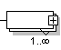 | Required field  Required, 1 to N values
 | Optional field
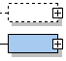 | Optional sub node  Required sub node
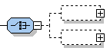 | Optional, but one of the two nodes should be provided
Integer | A 32 bit value
Date time | A date and time value in the following format:  YYYY-MM-DDTHH:MM:SS
 | Sequence to sub nodes
 | Used to indicate that only one of the included elements can be reported (Choice)

Description of XML Nodes

3.1.1 Node “report”
Basic information about Reporting Entity, reporting date and type of report. It can contain one or multiple transactions or describe an event (activity) without the need to report any transaction.

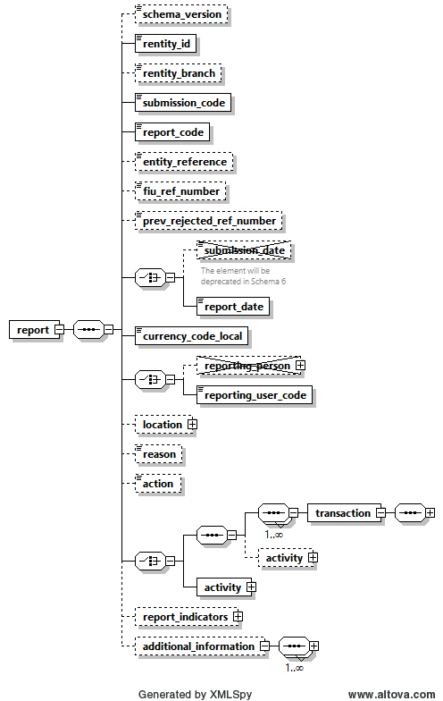
Figure 1: Overview node “report”

Name |  |  |  | #Schema  #App |  |  |  | Description |  |  |  | Length |  | Req. |  | Example
schema_version |  |  |  | Schema 5.0.1  App 5.1 |  |  |  | Host the schema version which was used to generate the XML. |  |  |  | 25 |  | N |  | 4.0.2  5.0.1
rentity_id |  |  |  |  |  |  |  | Reporting Entity number defined by FIC |  |  |  | Integer  >= 1 |  | Y |  | 1237
rentity_branch |  |  |  |  |  |  |  | Branch of current reporting entity. |  |  |  | 255 |  | N |  | Branch of Western Union who reported the transactions
submission_code |  |  |  |  |  |  |  | Type of submission |  |  |  | Enumeration |  | Y |  | See 5.1 Submission type
report_code |  |  |  |  |  |  |  | Type of transaction (STR/CTR) |  |  |  | Enumeration |  | Y |  | 5.8 Report Code
entity_reference |  |  |  |  |  |  |  | Optional reference to the report, used by reporting entity |  |  |  | 255 |  | N |  | STR Rep 392
FIC_ref_number |  |  |  |  |  |  |  | Optional ref. number to be used as communication channel between the FIC and the Reporting Entity when providing follow-up reports on the original report |  |  |  | 255 |  | N |  | STR20230225
prev_rejected_ref_number |  |  |  | Schema 5.0.1  App 5.1 |  |  |  | Ref Number of a rejected report, to allow the FIC to better follow-up on rejected reports (entity_ref_number or Original Web Report Key if entity_ref_number is not available) |  |  |  | 255 |  | N |  | 100-0-0
 | submission_date |  |  |  |  |  |  |  | Not in use |  |  |  | Not in use |  | Y |  | Not in use
 | report_date |  |  |  |  | Schema 5.0.1  App 5.0 |  |  | This is a suggestion to phase out the current “submission_date” and replace it with better name. |  |  |  | Datetime |  | Y |  | 2023-02-25T11:55:00
currency_code_  local |  |  |  |  |  |  |  | Local Currency code |  |  |  | Type “Currency-type” |  | Y |  | EUR
 | reporting_person |  |  |  |  |  |  |  | Not in use |  |  |  | Not in use |  | N
 | reporting_user_  code |  |  |  |  | Schema 5.0.1  App 5.0 |  |  | Currently, “reporting person” node can contain any name/details of a person, with no way to check if he/she is indeed a compliance officer in that RE. The “user_code” will be forced to have a valid user code of the RE or its delegation structure. |  |  |  | 50 |  | N |  | User1
Location |  |  |  |  |  |  |  | Describes location of the reported report |  |  |  | Type “t_address” |  | N |  | Mandatory: Same as “reporting pesrson”
reason |  |  |  |  |  |  |  | Why the report was reported (especially or STRs) |  |  |  | 4000 |  | N |  | Mandatory only on STR, SAR, TFR”
action |  |  |  |  |  |  |  | Describes action related to the report |  |  |  | 4000 |  | N |  | Mandatory only on STR, SAR, TFR”
 |  |  |  |  | transaction |  |  |  |  |  | type  transaction | Y |  |  |  | See 3.2 Node transaction
 |  |  |  |  | Activity (5.0) |  |  |  |  |  |  | N |  |  |  | Optional Activity in Transactional Report
 |  |  |  |  | Activity |  |  |  |  |  |  | Y |  |  |  | See 3.3 Node activity
report_indicators |  |  |  |  |  |  |  | List of indicators for the current reports |  |  |  | Type “indicator” |  | N |  | See 3.11 Subnode report_indicators [Mandatory to suspicious reports]
additional_information |  |  |  | Schema 5.0.1  App 5.2 |  |  |  | A new optional generic node for adding any unplanned extra information |  |  |  | Additional information type |  | N
Table 1: Details node “report”
3.1.2 Subnode report_indicators
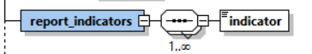

Figure 2: Overview subnode report_indicators

Name | Description | Length | Req. | Example
indicator | Some classification for the report | 25 | N  [Mandatory on suspicious reports such as STR,SAR,TFR] | Crime,  Terror Funding, etc.  (FIC predefined list of codes)

Note: Indicator are strictly mandatory when reporting suspicious reports such as STR,SAR,TFR,..

Table 2: Details subnode report_indicators

3.2.1 Node transaction
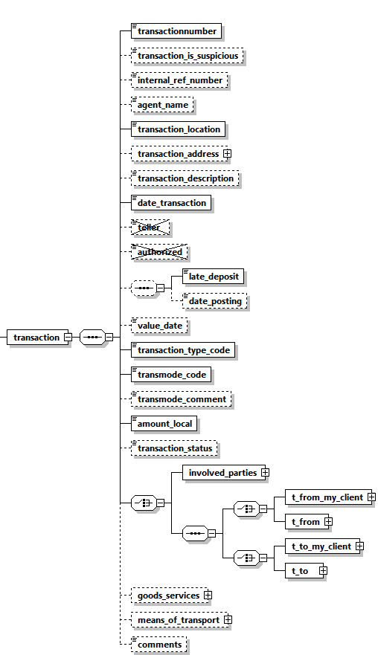

Figure 3: Overview node transaction

Name |  | #Schema  #App |  | Description |  | Length | Req. | Example
transactionnumber |  | Schema 5.0.1  App 5.1 |  | Unique transaction number for bank transaction |  | 100 | Y | 20084711
Transaction is suspicious |  | Schema 5.0.1  App 5.1 |  | Boolean |  |  | N
Internal_ref_number |  | Schema 5.0.1  App 5.1 |  | Reporting Entity internal transaction reference number |  | 100 | N | WU_BRNCH01_0001
agent name |  | Schema 5.0.1  App 5.1 |  | Hosts the agent name in money transfer agencies case when the report is done by main service provider |  | 255 | N | WU Agent
transaction_location |  |  |  | Branch/Location where the transaction took place |  | 255 | Y | Branch 001
Transaction Address |  | Schema 5.0.1  App 5.1 |  | Address of transaction place |  | Type “t_address” | N
transaction_ description |  |  |  | Free text field to describe the purpose of the transaction |  | 4000 | N
date_  transaction |  |  |  | Date and time of the transaction |  | DateTime | Y | 2006-03-25T11:55:00
teller |  |  |  | Not in use |  | 255 | N
authorized |  |  |  | Not in use |  | 20 | N | ID00033345
late_deposit and date_posting are both optional but when setting date_posting, late_deposit becomes mandatory.
3 possible combinations
1. none of the nodes is set
2. only late_deposit is set
3. late_deposit AND date_posting are set
late_deposit |  |  |  | Late deposit indicator |  | Boolean | N | True
date_  posting |  |  |  | Date of posting (if different from date of transaction) |  | DateTime | N | 2006-03-24T19:55:00
value_date |  |  |  | The actual date when the money will be credited (For example, Value date of a cheque) |  | DateTime | N | 2006-03-27T00:00:00
Transaction_Type |  | Schema 5.0.1  App 5.1 |  | answer the WHAT question while the current transaction_mode can be dedicated then to answer the HOW |  | Enumeration | N | see 5.18 Transaction Type
transmode_code |  |  |  | How the transaction was conducted |  | Enumeration | Y | See 5.6 Conduction Type
transmode_comment |  |  |  | Description if transmode_code is “O” (Other) |  | 50 | N | -
amount_  local |  |  |  | The value of the transaction in local currency |  | Decimal | Y
Transaction Status |  | Schema 5.0.1  App 5.1 |  | Describe if transaction was executed, on hold, blocked, ..etc. |  | Enumeration | N | see 5.19 Transaction Status
 |  | Transaction could be either a bi-party transaction with clear From and To sides, or a multi-party transaction with unlimited list of subjects (Persons, Accounts and Entities) where each has a role in the transaction rather than a clear from or to side.
 |  | Bi-Party Transaction
 |  |  | One of the nodes t_from_my_client or t_from should be provided. Both CANNOT be present together in a transaction, but one of them should be present.
 |  |  | t_from_my_client |  | Specifies where the money came from. If the source is reporting bank’s client, then this node should be provided | Subnode | Y  (one of them) | See t_from_my_client
 |  |  | t_from |  | Specifies where the money came from | Subnode | Y  (one of them) | See 3.42 Node t_from
 |  |  | One of the nodes t_to_my_client or t_to should be provided. Both CANNOT be present together in a transaction, but one of them should be present.
 |  |  | t_to_my_client |  | Specifies where the money went. If the destination is reporting bank’s client, then this node should be provided | Subnode | Y  (one of them) | See 3.51 Node t_to_my_client
 |  |  | t_to |  | Specifies where the money went. | Subnode | Y  (one of them) | See 3.52 Node t_to
 |  | Multi-Party Transaction
 |  |  | This is a new node in schema 3.0. It covers transactions with multi-party involvement covering non-banking transactions. Car dealers for example can report such transactions where more than one subject bought/sold a car, while the car dealer is not reported as part of the transaction but only as the reporting entity. If the transaction is reported in this way, then at least one “Party” node should be reported.
 |  |  | party |  | Describes the involved party details | Type “t_party” | Y | See 4.4 Type t_party
Goods_  services |  |  |  | The goods/services linked to the transaction |  | subnode | N | See 3.5 3.6 Subnode goods_services
means_of_  transport |  | Schema 5.0.1  App 5.2 |  | capture customs related reports where subjects carry money cross borders as well as possible TBML reporting |  | Subnode | N | 4.15 Means of Transportation Node
Comments |  |  |  | Additional comments |  | Type “comments_type”  Text 8000
Table 3: Details node transaction

3.2.2 Transaction Additional Info Type

Describes additional information in virtual currency and mobile money transactions regarding the used device, related IP address, blockchain block number and virtual address if the involved party is a Virtual Wallet.
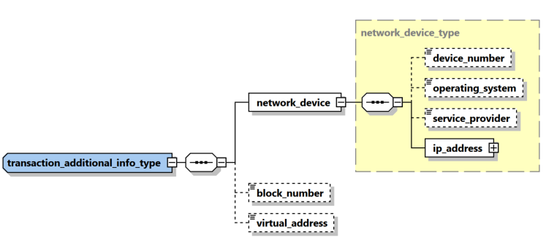

Name | #Schema  #App | Description | Length | Req. | Example
device_number | Schema 5.0.1  App 5.1 | The number of device to send/receive the money in transaction context | 50 | N | 06501234567
device_number | Schema 5.0.1  App 5.1 | The device operating system | Enumeration | N | iOS, Android, Windows, Mac OS, Linux…
service_provider | Schema 5.0.1  App 5.1 | The name of the service provider in case of mobile phone for example | 255 | N | Orange
ip_address | Schema 5.0.1  App 5.1 | Describes the details of the used “IP address” | Subnode | Y | See 4.8.2 IP Address Type
Block_number | Schema 5.0.1  App 5.1 | blockchain block number | Decimal | N
virtual_address | Schema 5.0.1  App 5.1 | virtual address if the involved party is a Virtual Wallet | 255 | N

3.3 Node Activity

Activity node was introduced first in schema 4.0 to represent an event where a list of subjects and goods are related directly to the report without the need of a transaction. In Schema 5, it was enhanced to include several new elements like set of “my client” PAE elements as well as country and “is suspected”. In addition, new schema supports since Application 5.0, a hybrid mode where set of one or many transactions can be followed by an activity node to allow reporting additional parties who are not involved directly in any of the reported transactions.

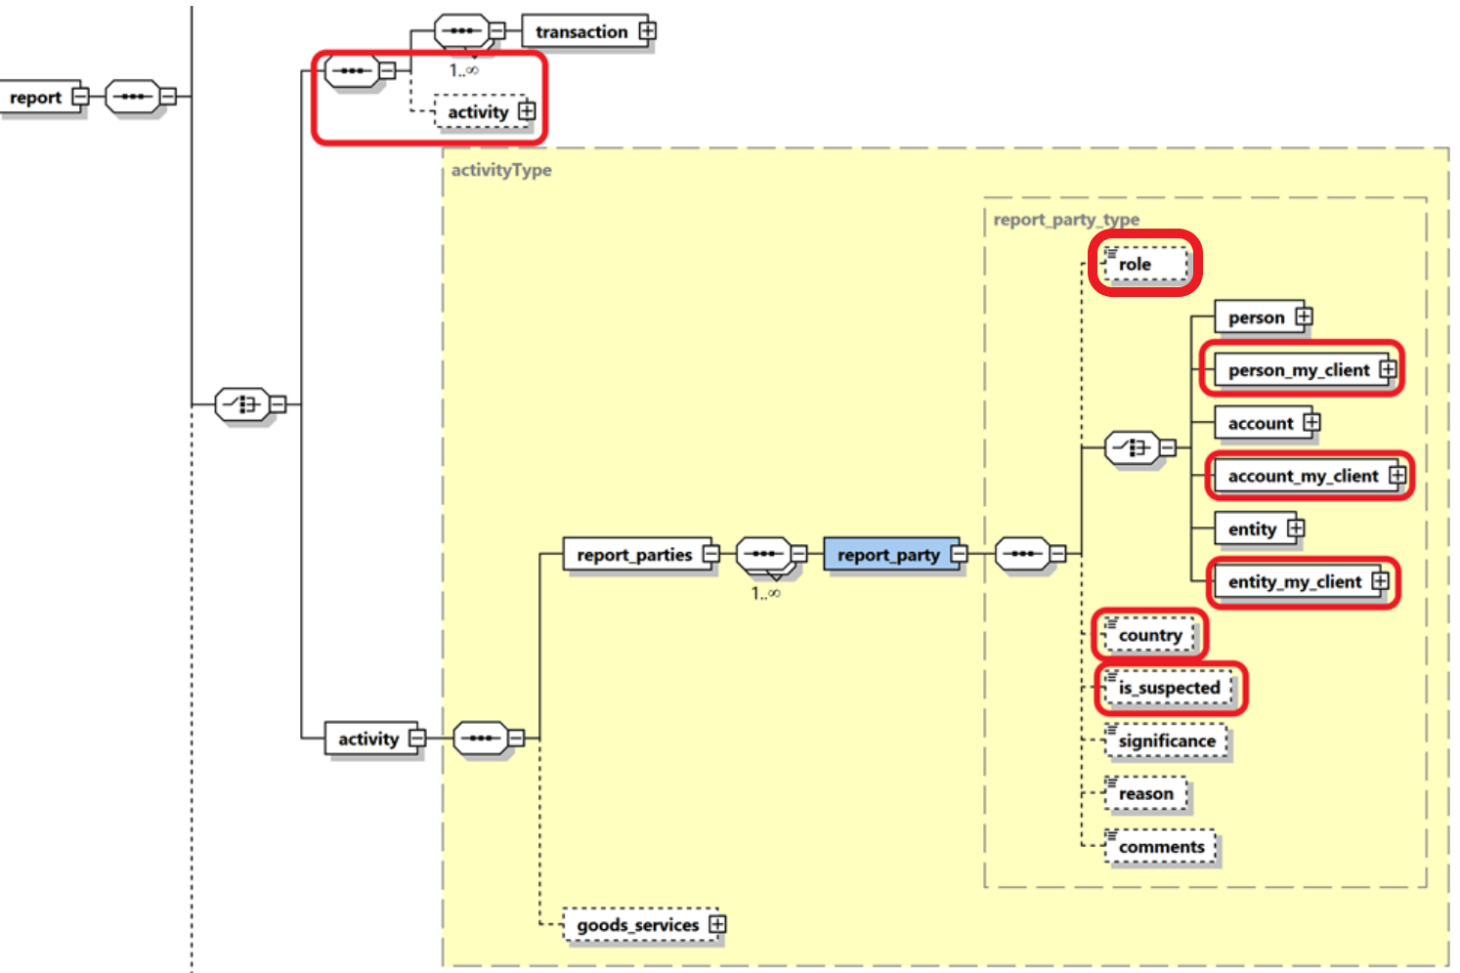

Figure 4: Overview node activity
Name | Description | Length | Req. | Example
report_parties | Represents a collection of involved subjects an involved subject with its details |  | Y
report_party | Represents a single involved subject with its details. At least one party should be included. | Type report_party_type | Y | See 4.9 Node report_party_type
goods_service | The standard goods_services node available in previous schemas | Type t_trans_item | N | -
Table 4: Details node activity

3.4.1 Node t_from_my_client

This node should be provided if the source side of the transaction is a client of the reporting entity.

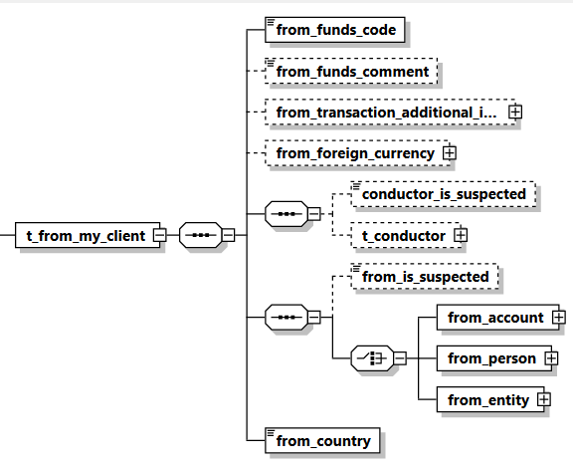

Figure 5: Overview node t_from_my_client

Name | #Schema  #App | Description | Length | Req. | Example
from_funds_  code |  | Type of funds used in initiating transaction | Enumeration | Y | See 5.2 Funds type
from_funds_  comment |  | Description, if funds_code is “O” (Other). | 255 | N | -
From transaction Additional Information | Schema 5.0.1  App 5.1 | covers Virtual Currency and Mobile Money related transaction element | Subnode | N | See
from_foreign_  currency |  | If the transaction is conducted in foreign currency, then specify the foreign currency details. | type  t_foreign_currency | N | See 4.7 Type t_foreign_currency
conductor_is_  suspected | Schema 5.0.1  App 5.1 | Indicates if the conductor is a suspected party in this transaction | Boolean | N | True/False
t_conductor | Schema 5.0.1  App 5.1 | The person performing the transaction | type  t_conductor_my_client | N | See 4.31 Type t_person_my_client
from_account |  | Subnode that holds account information | type t_account_my_client | Y  (one of them only) | See 4.11 Type t_account_my_client
from_person |  | Subnode that holds “from person” information. | Type  t_person_my_client | Y  (one of them only) | See 4.31 Type t_person_my_client
from_entity |  | Subnode that holds “from entity” information. | Type t_entity_my_client | Y  (one of them only) | See 4.32 Type t_entity_my_client
from_country |  | Country where transaction was initiated. | Enumeration | Y | See 5.14 Country Codes
Table 5: Details node t_from_my_client

3.4.2 Node t_from

This node should be provided if the source side of the transaction is NOT a client of the reporting entity.

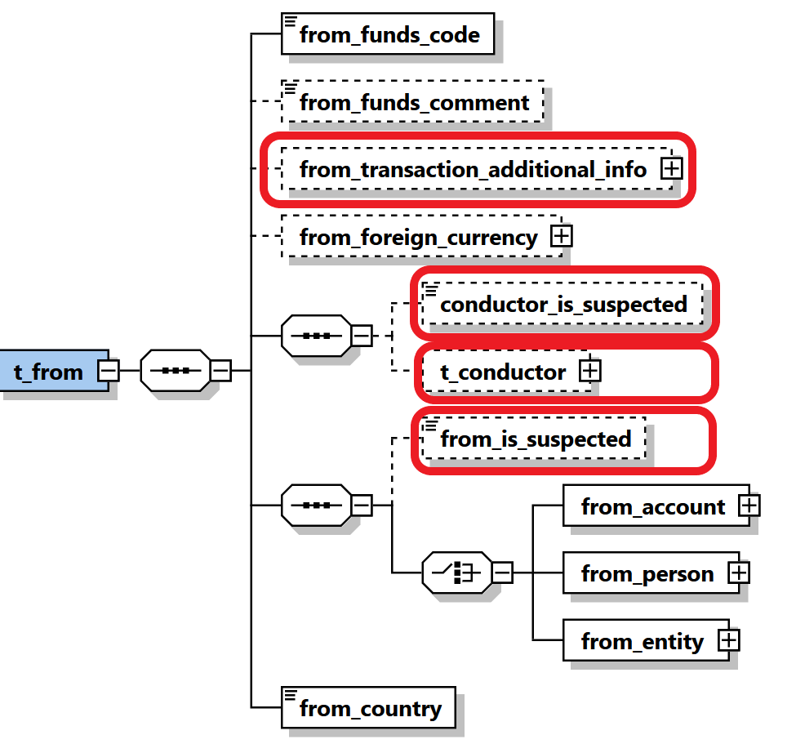
Figure 6: Overview node t_from

Name | #Schema  #App | Description | Length | Req. | Example
from_funds_  code |  | Type of funds used in initiating transaction | Enumeration | Y | See 5.2 Funds type
from_funds_  comment |  | Description, if funds_code is “O” (Other). | 255 | N | -
From transaction Additional Information | Schema 5.0.1  App 5.1 | covers Virtual Currency and Mobile Money related transaction element | Subnode | N | Transaction Additional Info Type
from_foreign_  currency |  | If the transaction is conducted in foreign currency, then specify the foreign currency details. | type  t_foreign_currency | N | See 4.7 Type t_foreign_currency
conductor_is_  suspected | Schema 5.0.1  App 5.1 | Indicates if the conductor is a suspected party in this transaction | Boolean | N | True/False
t_conductor | Schema 5.0.1  App 5.1 | The person performing the transaction | type  t_conductor | N | See 4.31 Type t_person_my_client
From_is_  suspected | Schema 5.0.1  App 5.1 | Indicates if the from party is a suspected party in this transaction | Boolean | N | True/False
from_account |  | Subnode that holds account information | type t_account | Y  (one of them only) | See 4.11 Type t_account_my_client
from_person |  | Subnode that holds “from person” information. | Type  t_person | Y  (one of them only) | See 4.31 Type t_person_my_client
from_entity |  | Subnode that holds “from entity” information. | Type t_entity | Y  (one of them only) | See 4.32 Type t_entity_my_client
from_country |  | Country where transaction was initiated. | Enumeration | Y | See 5.14 Country Codes

Table 6: Details node t_from

3.5.1 Node t_to_my_client

This node should be provided if the destination side of the transaction is a client of the reporting bank.

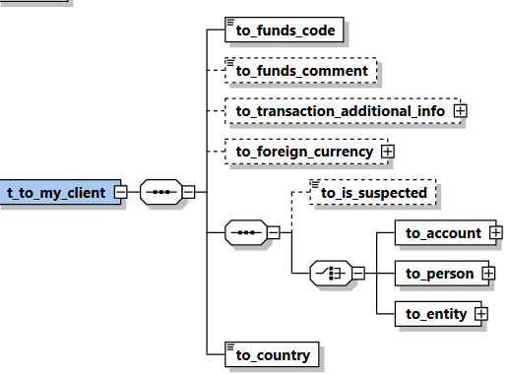

Figure 7: Overview node t_to_my_client

Name | #Schema  #App | Description | Length | Req. | Example
to_funds_code |  | Disposition of funds | Enumeration | Y | See 5.2 Funds type
to_funds_comment |  | Description, if funds_code is “O” (Other) or policy number. | 255 | N | -
to_transaction Additional Information | Schema 5.0.1  App 5.1 | covers Virtual Currency and Mobile Money related transaction element | Subnode | N | Transaction Additional Info Type
to_foreign_  currency |  | If the transaction is conducted in foreign currency, then specify the foreign currency details. | type  t_foreign_currency | N | See 4.7 Type t_foreign_currency
to_is_  suspected | Schema 5.0.1  App 5.1 | Indicates if the “to” party is a suspected party in this transaction | Boolean | N | True/False
to_account |  | Subnode that holds account information | type t_account_my_client | Y  (one of them) | See 4.11 Type t_account_my_client
to_person |  | Subnode that holds person information | type t_person_my_client | Y  (one of them) | See 4.31 Type t_person_my_client
to_entity |  | Subnode that holds “to entity” information. | Type t_entity_my_client | Y  (one of them) | See 4.32 Type t_entity_my_client
to_country |  | Target country of the transaction | Enumeration | Y | See 5.14 Country Codes
Table 7: Details node t_to_my_client

3.5.2 Node t_to

Information about the transaction disposition(s) - i.e. where the money went.
t_to can either point to a person or to an account.
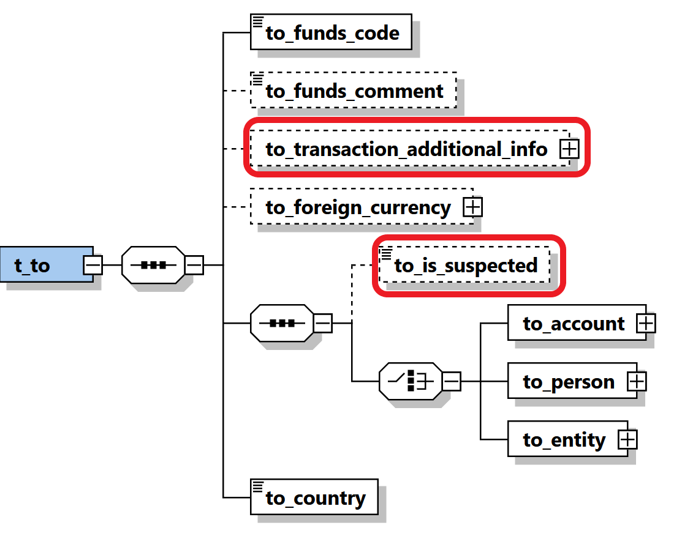
Figure 8: Overview node t_to
Name | #Schema  #App | Description | Length | Req. | Example
to_funds_code |  | Disposition of funds | Enumeration | Y | See 5.2 Funds type
to_funds_comment |  | Description, if funds_code is “O” (Other) or policy number. | 255 | N | -
to_transaction Additional Information | Schema 5.0.1  App 5.1 | covers Virtual Currency and Mobile Money related transaction element | Subnode | N | Transaction Additional Info Type
to_foreign_  currency |  | If the transaction is conducted in foreign currency, then specify the foreign currency details. | type  t_foreign_currency | N | See 4.7 Type t_foreign_currency
to_is_  suspected | Schema 5.0.1  App 5.1 | Indicates if the “to” party is a suspected party in this transaction | Boolean | N | True/False
to_account |  | Subnode that holds account information | type t_account | Y  (one of them) | See 4.11 t_account_my_client
to_person |  | Subnode that holds person information | type t_person | Y  (one of them) | See 4.31 t_person_my_client
to_entity |  | Subnode that holds “to entity” information. | Type t_entity | Y  (one of them) | See 4.32 t_entity_my_client
to_country |  | Target country of the transaction | Enumeration | Y | See 5.14 Country Codes
Table 8: Details node t_to

3.6.1 Node t_party
This type is used to represent Multi-Party transaction parties

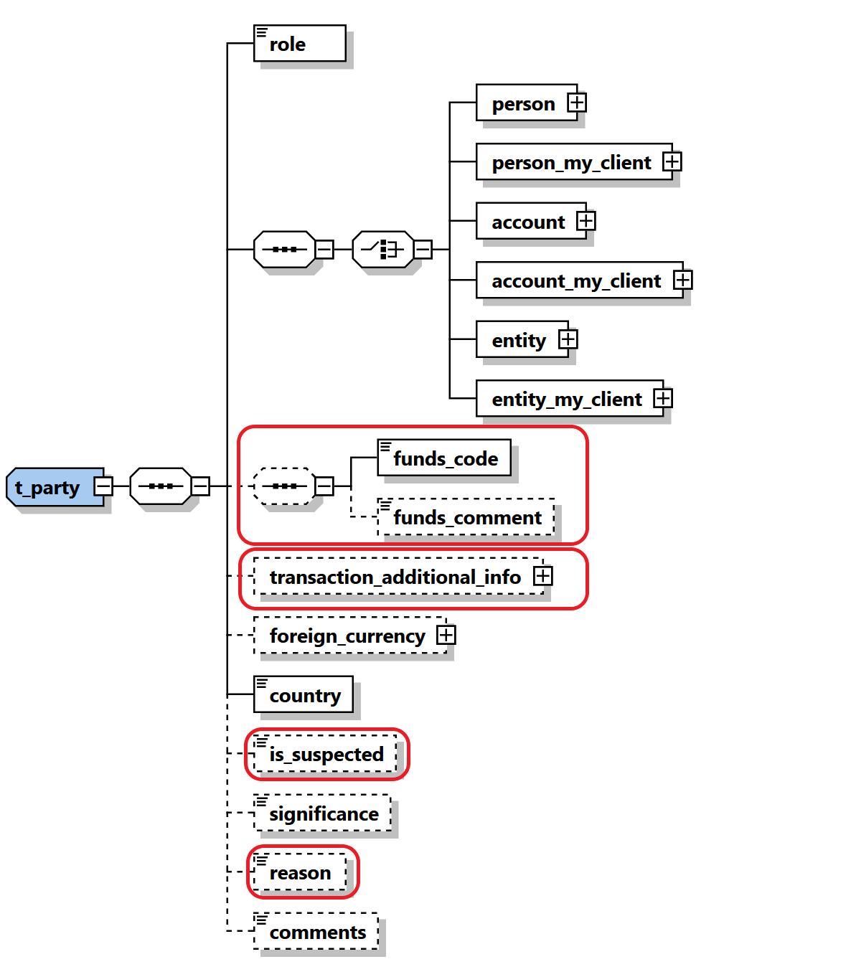
Figure 9: Overview type t_party

Name |  | #Schema  #App | Description | Length | Req. | Example
role |  |  | Subject role in the transaction | Enumeration | Y | Buyer, Seller,..
 | Subject: One occurrence of the supported subject types must be included.
Person |  |  | Involved Person | Type “t_person” | Y | See 4.32 Type t_person
Person_my_client |  |  | Involved Person | Type “t_person_  my_client” | Y | See 4.31 Type t_person_my_client
account |  |  | Involved Account | Type “t_account” | Y | See 4.12 Type t_account
account_  my_client |  |  | Involved Account | Type “t_ account_my_client” | Y | See 4.11 Type t_account_my_client
entity |  |  | Involved Entity | Type “t_ entity” | Y | See 4.22 Type t_entity
entity_my_client |  |  | Involved Entity | Type “t_ entity_my_client” | Y
funds_code |  |  | Type of funds used in initiating transaction | Enumeration | N | See 5.2 Funds type
funds_comment |  |  | Description, if funds_code is “O” (Other). | 255 | N | -
transaction Additional Information |  | Schema 5.0.1  App 5.1 | covers Virtual Currency and Mobile Money related transaction element | Subnode | N | Transaction Additional Info Type
foreign_currency |  |  | If the transaction is conducted in foreign currency, then specify the foreign currency details. | type  t_foreign_currency | N | See 4.7 Type t_foreign_currency
country |  |  | Country of the transaction | Enumeration | Y | See 5.14 Country Codes
is_  suspected |  | Schema 5.0.1  App 5.1 | Indicates if the “to” party is a suspected party in this transaction | Boolean | N | True/False
significance |  |  | The significance of the subject in the transaction | Integer | N | 0-10
Reason |  | Schema 5.0.1  App 5.1 | Describe the reason why the party is included | 8000 | N
comments |  |  | Generic comments | 8000 | N

Table 9: Details type t_party

3.7 Subnode goods_services
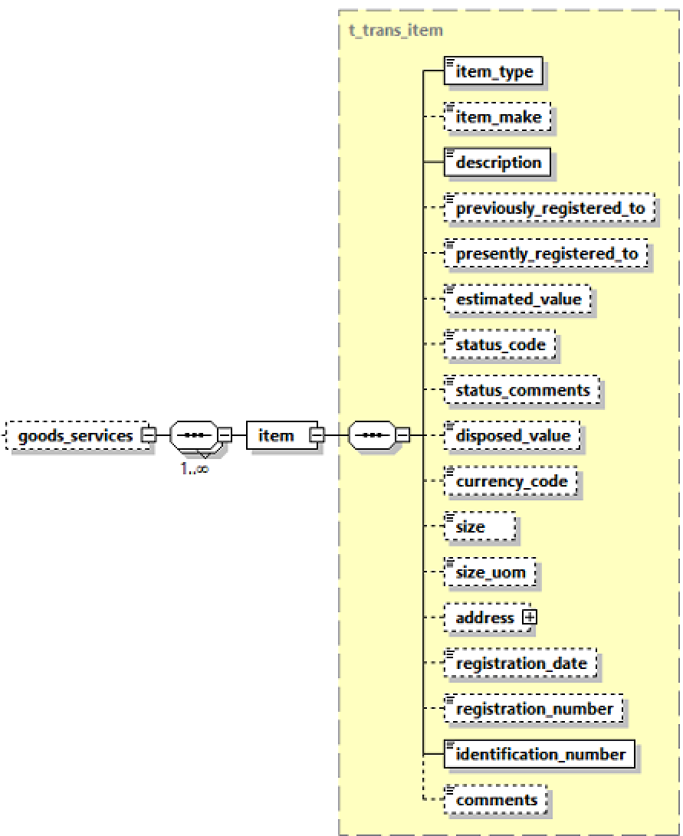

Figure 9: Overview subnode goods_services
Name | Description | Length | Req. | Example
Item_type | Lookup code describes the item type | Type “trans_item_type” | Y | C = Car  L = Land
Item_make | Item Maker | 255 | N | In case of Car for example, BMW
description | Description of item | 8000 | N | Apartment building
previously_registered_to | Name of previous owner | 500 | N | John Smith
presently_registered_to | Name of current owner | 500 | N | Jane Smith
estimated_value | Estimated value of the property – Used Currency is the one specified in node from_currency | Decimal | Y | 250000.00
status_code | Status code | Enumeration | N | See 5.7 Transaction Item Status
status_comments | Status Comments | 500 | N
disposed_value | effective value for property transfer – Used Currency is the one specified in node from_currency | Decimal | N | 500000.00
Currency_code | used to report service conducted in foreign currency | Enumeration | N | See 5.13 Currencies
size | Size of the property – in unit specified in node size_uom | Decimal | N | 150
size_uom | Unit of measurement | 250 | N | Square meters
address | Address of the property | type t_address | N | 4.5 Type t_address
registration_date | Official registration date | DateTime | N | 2001-12-17T09:30:47
registration_number | Official registration number | 500 | N | Car VIN Number
Identification_number | Any number that can identify the item | 255 | Y | Car Plate Number
Comments | Additional comments | 8000 | N
Table 9: Details subnode goods_services

Description Of Common Types Used in the Schema

4.1.1 Type t_account_my_client/t_account
The structure of these 2 types is exactly the same, it is introduced just to allow FICs to add more restrictions when the account is the hosted in the reporting entity in comparison to an account of another RE. i.e., some nodes which are not mandatory in t_account can be set mandatory in t_account_my_client.

The logic here is that whenever the involved account or person is the client of the reporting entity, more details may be demanded, and the reporting entity must have the information as part of the adherence to the “Know Your Customer” (KYC) philosophy of compliance.
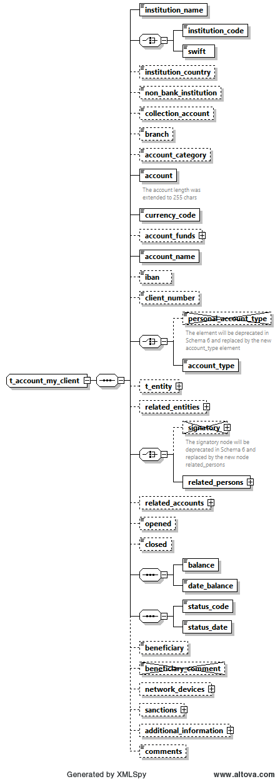
Figure 10: Overview type t_account_my_client/
Name |  | #Schema  #App |  |  | Description |  | Length |  |  | Req. |  | Example
Instituation_name |  |  |  |  | The name of the Bank |  | 255 |  |  | Y |  | Bank of …
 | institution_code |  |  |  |  | Institution code |  |  | 50 |  | Y  (one of them) |  | -
 | swift |  |  |  |  | SWIFT code according to ISO 9362 |  |  | 11 |  |  |  | ATTBVI
Institution Country |  | Schema 5.0.1  App 5.1 |  |  | The country of the reported bank especially relevant for foreign banks |  | Enumeration |  |  | N |  | UN
Non_banking_  institution |  |  |  |  | Notification that an account is not opened in bank |  | Boolean |  |  | N |  | True/False
Collection Account |  | Schema 5.0.1  App 5.1 |  |  | Indicate that the reported account is a collection account and is not owned really by the reported subject |  | Boolean |  |  | N |  | True/False
Branch |  |  |  |  | Branch code or name |  | 255 |  |  | N |  | ABX12
Account Category |  | Schema 5.0.1  App 5.1 |  |  | Allow different presentations of the Account element, e.g., Account, IBAN, Payment Card, Email, Mobile number as well as Virtual Addresses and Wallets |  | Enumeration |  |  | N |  | IBAN
Account |  | Schema 5.0.1  App 5.1 |  |  | Account number  Enlarged and can host now as well IBAN, Wallet, Virtual Address, etc. |  | 50  255 |  |  | Y |  | 31032027088
currency_code |  |  |  |  | Currency the account is kept in |  | Enumeration |  |  | Y |  | See 5.13 Currencies
Account Funds |  | Schema 5.0.1  App 5.1 |  |  | allow capturing different funds for the same account. This will be implemented first to handle Wallet funds but can be extended later to host different currencies in one main account for example. |  | SubNode |  |  | N |  | See 4.1.6 Type Account Funds
account_name |  |  |  |  | This is a free text field used to “Label” the account, for example a saving book account with anonymous owner, or an Entity account dedicated to Invoices, etc. |  | 255 |  |  | Y |  | Private savings account
iban |  |  |  |  | LT601010012345678901 |  | 34 |  |  | N |  | LT601010012345678901
 | personal_account_type |  |  |  |  | Account Type  Will be deprecated in the next schema |  | Enumeration |  |  | N |  | See 5.3 Account type
 | account_type |  |  | Schema 5.0.1  App 5.1 |  | Same as Account Type, jus better name since the type is the same for private of business accounts |  | Enumeration |  |  | Y |  | See 5.3 Account type
t_entity |  |  |  |  | Business entity owning the account |  | type  t_entity |  |  | N |  | See 4.22 Type t_entity
related_entities |  | Schema 5.0.1  App 5.1 |  |  | A new one to many relations to allow Reporting Entities to report several entities having some kind of relation to an account in addition to the current Entity owning the account node. |  | Subnode |  |  | N |  | See 4.1.5 Type Account Related Entity
 | signatory |  |  |  |  | Person(s) with access to the account. |  | Not in use |  |  | N
 | related_persons |  |  | Schema 5.0.1  App 5.1 |  | New Choice was introduced to allow deprecating the current root level Signatory node and replace it with cover node related_persons with multiple occurrences of single related_person element. |  | Subnode |  |  | Y |  | 4.1.3 Type Account Related Persons
related_accounts |  | Schema 5.0.1  App 5.1 |  |  | A new one to many relations to allow Reporting Entities to report several accounts as related to the main reported account |  | SubNode |  |  | N |  | 4.1.4 Type Account Related Accounts
opened |  |  |  |  | Date account opened |  | DateTime |  |  | N |  | 2003-01-25T00:00:00
closed |  |  |  |  | Date account closed |  | DateTime |  |  | N |  | 2006-03-25T00:00:00
balance |  |  |  |  | The account balance after the transaction was conducted. |  | Decimal |  |  | N |  | 5000.50
date_balance |  |  |  |  | A date to specify the date of the reported balance. Application will show balance history |  | DateTime |  |  | Y
status_code |  |  |  |  | Account status when transaction was initiated |  | Enumeration |  |  | Y |  | 5.4 Account status type
Status_date |  | Schema 5.0.1  App 5.1 |  |  | A date to specify the date of the account status. Application will show balance history |  | DateTime |  |  | Y
network_devices |  | Schema 5.0.1  App 5.2 |  |  | Supports multi occurrence of “Network device” |  | Subnode |  |  | N |  | 4.9.1 Network Device Type
beneficiary |  |  |  |  | Ultimate beneficiary of the account. |  | 50 |  |  | N |  | Kalisa
beneficiary_  comment |  |  |  |  | Not in use.
sanctions |  | Schema 5.0.1  App 5.2 |  |  | supports multi occurrence of “sanction list”. |  | Subnode |  |  | N |  | 4.13 Sanctions Node
additional_  information |  | Schema 5.0.1  App 5.2 |  |  | A new optional generic node for adding any unplanned extra information. See dedicated section. |  | SubNode |  |  | N |  | 4.12 Additional Information
comments |  |  |  |  | Generic comments elements |  | 8000 |  |  | N
Table 10: Details type t_account_my_client

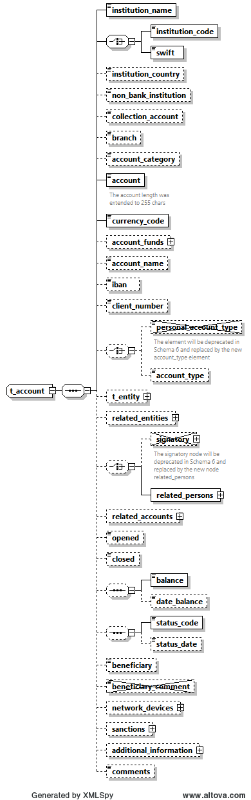
Figure 10: Overview type t_account

Name |  | #Schema  #App |  |  | Description |  | Length |  |  | Req. |  | Example
Instituation_name |  |  |  |  | The name of the Bank |  | 255 |  |  | Y |  | Bank of …
 | institution_code |  |  |  |  | Institution code |  |  | 50 |  | Y  (one of them) |  | -
 | swift |  |  |  |  | SWIFT code according to ISO 9362 |  |  | 11 |  |  |  | ATTBVI
Institution Country |  | Schema 5.0.1  App 5.1 |  |  | The country of the reported bank especially relevant for foreign banks |  | Enumeration |  |  | N |  | UN
Non_banking_  institution |  |  |  |  | Notification that an account is not opened in bank |  | Boolean |  |  | N |  | True/False
Collection Account |  | Schema 5.0.1  App 5.1 |  |  | Indicate that the reported account is a collection account and is not owned really by the reported subject |  | Boolean |  |  | N |  | True/False
Branch |  |  |  |  | Branch code or name |  | 255 |  |  | N |  | ABX12
Account Category |  | Schema 5.0.1  App 5.1 |  |  | Allow different presentations of the Account element, e.g., Account, IBAN, Payment Card, Email, Mobile number as well as Virtual Addresses and Wallets |  | Enumeration |  |  | N |  | IBAN
Account |  | Schema 5.0.1  App 5.1 |  |  | Account number  Enlarged and can host now as well IBAN, Wallet, Virtual Address, etc. |  | 50  255 |  |  | Y |  | 31032027088
currency_code |  |  |  |  | Currency the account is kept in |  | Enumeration |  |  | Y |  | See 5.13 Currencies
Account Funds |  | Schema 5.0.1  App 5.1 |  |  | allow capturing different funds for the same account. This will be implemented first to handle Wallet funds but can be extended later to host different currencies in one main account for example. |  | SubNode |  |  | N |  | See 4.1.6 Type Account Funds
account_name |  |  |  |  | This is a free text field used to “Label” the account, for example a saving book account with anonymous owner, or an Entity account dedicated to Invoices, etc. |  | 255 |  |  | N |  | Private savings account
iban |  |  |  |  | LT601010012345678901 |  | 34 |  |  | N |  | LT601010012345678901
 | personal_account_type |  |  |  |  | Account Type  Will be deprecated in the next schema |  | Enumeration |  |  | N |  | See 5.3 Account type
 | account_type |  |  | Schema 5.0.1  App 5.1 |  | Same as Account Type, jus better name since the type is the same for private of business accounts |  | Enumeration |  |  | N |  | See 5.3 Account type
t_entity |  |  |  |  | Business entity owning the account |  | type  t_entity |  |  | N |  | See 4.22 Type t_entity
related_entities |  | Schema 5.0.1  App 5.1 |  |  | A new one to many relations to allow Reporting Entities to report several entities having some kind of relation to an account in addition to the current Entity owning the account node. |  | Subnode |  |  | N |  | See 4.1.5 Type Account Related Entity
 | signatory |  |  |  |  | Person(s) with access to the account. |  | Subnode (can repeated to specify multiple signatories). Note that the node t_person is of type t_person_my_client |  |  | N |  | See 4.1.2 Type Signatory
 | related_persons |  |  | Schema 5.0.1  App 5.1 |  | New Choice was introduced to allow deprecating the current root level Signatory node and replace it with cover node related_persons with multiple occurrences of single related_person element. |  | Subnode |  |  | N |  | 4.1.3 Type Account Related Persons
related_accounts |  | Schema 5.0.1  App 5.1 |  |  | A new one to many relations to allow Reporting Entities to report several accounts as related to the main reported account |  | SubNode |  |  | N |  | 4.1.4 Type Account Related Accounts
opened |  |  |  |  | Date account opened |  | DateTime |  |  | N |  | 2003-01-25T00:00:00
closed |  |  |  |  | Date account closed |  | DateTime |  |  | N |  | 2006-03-25T00:00:00
balance |  |  |  |  | The account balance after the transaction was conducted. |  | Decimal |  |  | N |  | 5000.50
date_balance |  |  |  |  | A date to specify the date of the reported balance. Application will show balance history |  | DateTime |  |  | N
status_code |  |  |  |  | Account status when transaction was initiated |  | Enumeration |  |  | N |  | 5.4 Account status type
Status_date |  | Schema 5.0.1  App 5.1 |  |  | A date to specify the date of the account status. Application will show balance history |  | DateTime |  |  | N
network_devices |  | Schema 5.0.1  App 5.2 |  |  | Supports multi occurrence of “Network device” |  | Subnode |  |  | N |  | 4.9.1 Network Device Type
beneficiary |  |  |  |  | Ultimate beneficiary of the account. |  | 50 |  |  | N |  | Kalisa
beneficiary_  comment |  |  |  |  | Not in use.
sanctions |  | Schema 5.0.1  App 5.2 |  |  | supports multi occurrence of “sanction list”. |  | Subnode |  |  | N |  | 4.13 Sanctions Node
additional_  information |  | Schema 5.0.1  App 5.2 |  |  | A new optional generic node for adding any unplanned extra information. See dedicated section. |  | SubNode |  |  | N |  | 4.12 Additional Information
comments |  |  |  |  | Generic comments elements |  | 8000 |  |  | N
Table 11: Details type t_account

4.1.2 Type Signatory(In our context this node is not active as it was replaced by Account related persons)

is_primary | Note in use | Identifies the primary account holder. Only one signatory may be marked as is_primary. Has to be ‘true’ when node is set. | fixed = 1 | N
t_person | Note in use | Subnode holding detailed information about the signatory. Mandatory for signatories in the XML report. | type  t_person_my_client | Y | See 4.31 Type t_persony
role | Note in use | Subnode holding enumeration about the role of current signatory with the account. report. | type  “account_person_role_type” | N

4.1.3 Type Account Related Persons
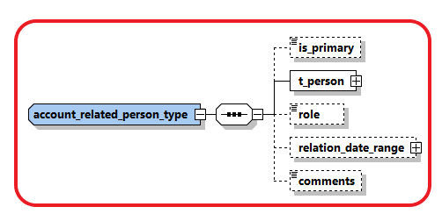
is_primary |  | Identifies the primary account holder. Only one signatory may be marked as is_primary. Has to be ‘true’ when node is set. | fixed = 1 | N
t_person |  | Subnode holding detailed information about the signatory. Mandatory for signatories in the XML report. | type  t_person | Y | See 4.31 Type t_person
role |  | Subnode holding enumeration about the role of current signatory with the account. report. | type  “account_person_role_type” | N
relation_date_range | Schema 5.0.1  App 5.1 | Subnode to describe the date range relation | Type “relation_data_range_type” | N
comments |  | Generic Comments | 8000 | N

4.1.4 Type Account Related Accounts
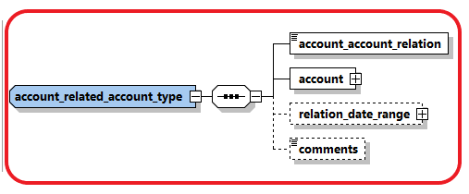
account_account_  relation | Schema 5.0.1  App 5.1 | Describe the relation between the related two accounts | enumeration | Y
account |  | Subnode holding detailed information about the Related Account. | type  t_account | Y | See 4.31 Type t_account
relation_date_range |  | Subnode to describe the date range relation | Type “relation_data_range_type” | N
comments |  | Gneric Comments | 8000 | N

4.1.5 Type Account Related Entity
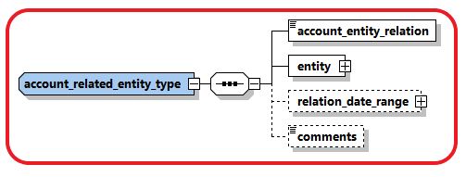
account_entity_  relation | Schema 5.0.1  App 5.1 | Describe the relation between the account and related entity | enumeration | Y
entity |  | Subnode holding detailed information about the related entity. | type  t_entity | Y | See 4.31 Type t_entity
relation_date_range |  | Subnode to describe the date range relation | Type “relation_data_range_type” | N
comments |  | Generic Comments | 8000 | N

4.1.6 Type Account Funds
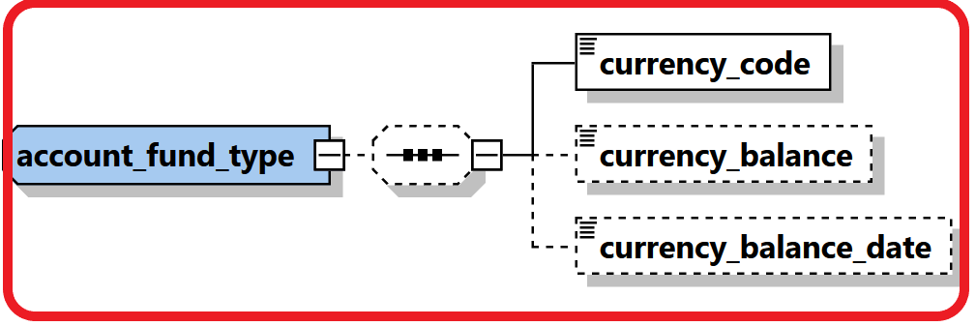

currency_code | Schema 5.0.1  App 5.1 | Describe the currency of the funds | enumeration | Y
currency_balance | Schema 5.0.1  App 5.1 | Balance of the funds. | Decimal | N
currency_balance_date | Schema 5.0.1  App 5.1 | Balance of the funds. | DateTime” | N

4.2.1 Type t_entity_my_client/t_entity

The structure of these 2 types is exactly the same, it is introduced just to allow more restrictions when the entity is hosted in the reporting entity in comparison to an entity which is the customer of another RE. i.e., some nodes which are not mandatory in t_entity can be set mandatory in t_entity_my_client.
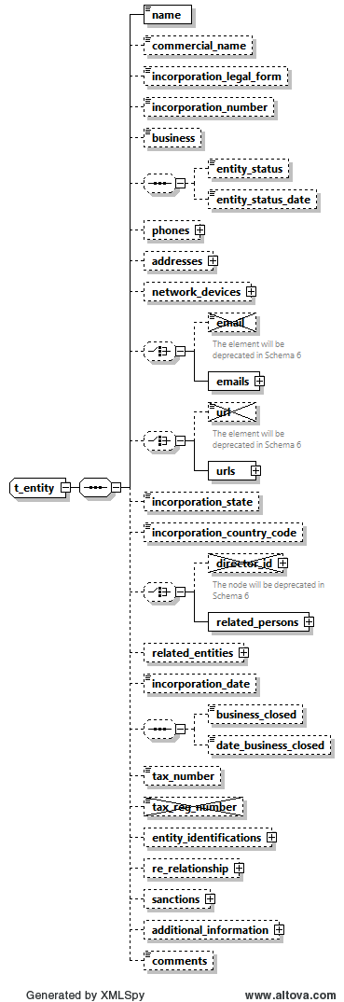
Figure 5: Overview type t_entity/
Name |  | #Schema  #App |  |  | Description |  | Length |  | Req. |  | Example
Name |  |  |  |  | Name of Entity |  | 255 |  | Y |  | DoeComp
Commercial_name |  |  |  |  | The “traded as” name of the entity |  | 255 |  | N
Incorporation_legal_form |  |  |  |  | The legal form of the entity |  | Type “legal_form_type” |  | N |  | See 5.11  Ltd., GmbH,
incorporation_  number |  |  |  |  | The registration number of the entity/"company" in the relevant authority (e.g. Chamber of Commerce) |  | 50 |  | N |  | C845900
Business |  |  |  |  | Nature of business activities from NACE v.2 code list published by FIU-LV (provide a code or multiple semicolon-separated codes) |  | Text 255 |  | N
Entity Status |  | Schema 5.0.1  App 5.2 |  |  | describing the status of the entity |  | Enumeration |  | N |  | ACTIVE
Entity Status Date |  | Schema 5.0.1  App 5.2 |  |  | describing the date of entity status |  | DateTime |  | N
Phones |  |  |  |  | A Holder node for a 1..many Phones |  |  |  | N
Phone |  |  |  |  | One occurrence of phone node |  | Type “t_phone” |  | N  When “Phones” is provided |  | See 4.6 Type t_phone
Addresses |  |  |  |  | A Holder node for a 1..many Addresses |  |  |  | N
Address |  |  |  |  | One occurrence of address node |  | Type “t_address” |  | N  When “Addresses” is provided |  | 4.5 Type t_address
network_devices |  | Schema 5.0.1  App 5.2 |  |  | supports multi occurrence of “network device”. |  | Subnode |  | N |  | See 4.8.1 Network Device Type
 | Email |  |  |  |  | Not in use |  | email_address (255) |  |  | N |  | test@mail.com
 | emails |  |  | Schema 5.0.1  App 5.2 |  | supports several emails for the reported entity in comparison with currently one email |  | email_address (255) |  |  | N
 | url |  |  |  |  | Not in use |  | 255 |  |  | N |  | www.entity.com
 | urls |  |  |  |  | supports several urls for the reported entity in comparison with currently one url |  | 255 |  |  | N |  | www.entity.com
Incorporation_state |  |  |  |  | State/Province |  |  |  | N
incorporation_  country_code |  |  |  |  | Country |  | Enumeration |  | Y |  | See 5.14 Country Codes
 | director_id |  |  |  |  | Not in use |  | Not in use |  | N |  | See 4.31 Type t_person/t_person_my_client
 | related_persons |  | Schema 5.0.1  App 5.2 |  |  | Parent node for multiple related_persons. Director_id will be deprecated in future schemas. |  | subnode |  | N |  | See 4.2.2 Type Entity Related Persons
related_entities |  | Schema 5.0.1  App 5.0 |  |  | Supports creating relations between different entities |  | Subnode |  | N |  | See 4.2.3 Type Entity Related Entities
incorporation_date |  |  |  |  | Incorporation registration date |  | Date |  | N
business_closed |  |  |  |  | Boolean to indicate if the company is closed down |  | Boolean |  | N
date_business_  closed |  |  |  |  | If entity is closed then specify close date if any. |  | Date |  | N
tax_numebr |  |  |  |  | The entity tax number |  | 100 |  | N
tax_registeration_  number |  |  |  |  | Not in use
entity_identifications |  | Schema 5.0.1  App 5.2 |  |  | Similar to Person Identifications, a repeated sub node for Entity identification numbers was introduced. |  | Subnode |  | N |  | See 4.2.4 Type Entity Identifications
business relationship |  | Schema 5.0.1  App 5.2 |  |  | host the starting and dates of the relationship between the Reporting Entity and the Entity |  | Subnode |  | N |  | 4.12 Business Relationship
sanctions |  | Schema 5.0.1  App 5.2 |  |  | supports multi occurrence of “sanction list”. |  | Subnode |  | N |  | 4.13 Sanctions Node
additional_  information |  | Schema 5.0.1  App 5.2 |  |  | A new optional generic node for adding any unplanned extra information. See dedicated section. |  | SubNode |  | N |  | 4.12 Additional Information
Comments |  |  |  |  | Generic comments field |  | 8000 |  | N

Table 5: Details type t_entity

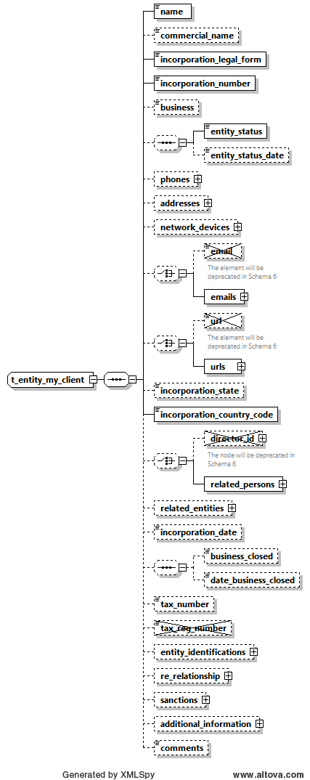
Figure 6: Overview type t_entity My_Client

Name |  | #Schema  #App |  |  | Description |  | Length |  | Req. |  | Example
Name |  |  |  |  | Name of Entity |  | 255 |  | Y |  | DoeComp
Commercial_name |  |  |  |  | The “traded as” name of the entity |  | 255 |  | N
Incorporation_legal_form |  |  |  |  | The legal form of the entity |  | Type “legal_form_type” |  | Y |  | See 5.11  Ltd., GmbH,
incorporation_  number |  |  |  |  | The registration number of the entity/"company" in the relevant authority (e.g. Chamber of Commerce) |  | 50 |  | Y |  | C845900
Business |  |  |  |  | Nature of business activities from NACE v.2 code list published by FIU-LV (provide a code or multiple semicolon-separated codes) |  | Text 255
Entity Status |  | Schema 5.0.1  App 5.2 |  |  | describing the status of the entity |  | Enumeration |  | N |  | ACTIVE
Entity Status Date |  | Schema 5.0.1  App 5.2 |  |  | describing the date of entity status |  | DateTime |  | N
Phones |  |  |  |  | A Holder node for a 1..many Phones |  |  |  | N
Phone |  |  |  |  | One occurrence of phone node |  | Type “t_phone” |  | N  When “Phones” is provided |  | See 4.6 Type t_phone
Addresses |  |  |  |  | A Holder node for a 1..many Addresses |  |  |  | N
Address |  |  |  |  | One occurrence of address node |  | Type “t_address” |  | N  When “Addresses” is provided |  | 4.5 Type t_address
network_devices |  | Schema 5.0.1  App 5.2 |  |  | supports multi occurrence of “network device”. |  | Subnode |  | N |  | See 4.8.1 Network Device Type
 | Email |  |  |  |  | Not in use |  | email_address (255) |  |  | N |  | test@mail.com
 | emails |  |  | Schema 5.0.1  App 5.2 |  | supports several emails for the reported entity in comparison with currently one email |  | email_address (255) |  |  | N
 | url |  |  |  |  | Not in use |  | 255 |  |  | N |  | www.entity.com
 | urls |  |  |  |  | supports several urls for the reported entity in comparison with currently one url |  | 255 |  |  | N |  | www.entity.com
Incorporation_state |  |  |  |  | State/Province |  |  |  | N
incorporation_  country_code |  |  |  |  | Country |  | Enumeration |  | Y |  | See 5.14 Country Codes
 | director_id |  |  |  |  | Not in use |  |  |  | N |  | See 4.31 Type t_person/t_person_my_client
 | related_persons |  | Schema 5.0.1  App 5.2 |  |  | Parent node for multiple related_persons. Director_id will be deprecated in future schemas. |  | subnode |  | N |  | See 4.2.2 Type Entity Related Persons
related_entities |  | Schema 5.0.1  App 5.0 |  |  | Supports creating relations between different entities |  | Subnode |  | N |  | See 4.2.3 Type Entity Related Entities
incorporation_date |  |  |  |  | Incorporation registration date |  | Date |  | N
business_closed |  |  |  |  | Boolean to indicate if the company is closed down |  | Boolean |  | N
date_business_  closed |  |  |  |  | If entity is closed then specify close date if any. |  | Date |  | N
tax_numebr |  |  |  |  | The entity tax number |  | 100 |  | N
tax_registeration_  number |  |  |  |  | Not in use
entity_identifications |  | Schema 5.0.1  App 5.2 |  |  | Similar to Person Identifications, a repeated sub node for Entity identification numbers was introduced. |  | Subnode |  | N |  | See 4.2.4 Type Entity Identifications
business relationship |  | Schema 5.0.1  App 5.2 |  |  | host the starting and dates of the relationship between the Reporting Entity and the Entity |  | Subnode |  | N |  | 4.12 Business Relationship
sanctions |  | Schema 5.0.1  App 5.2 |  |  | supports multi occurrence of “sanction list”. |  | Subnode |  | N |  | 4.13 Sanctions Node
additional_  information |  | Schema 5.0.1  App 5.2 |  |  | A new optional generic node for adding any unplanned extra information. See dedicated section. |  | SubNode |  | N |  | 4.12 Additional Information
Comments |  |  |  |  | Generic comments field |  | 8000 |  | N
Table 6: Details type t_entity My_Client

4.2.2 Type Entity Related Persons

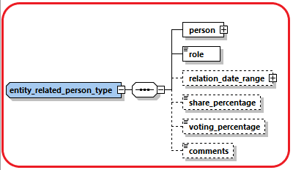

person |  | Subnode holding detailed information about the signatory. | type  t_person | Y | See 4.31 Type t_person
role |  | Subnode holding enumeration about the role of current signatory in the entity | type  “entity_person_role_type” | N | 5.16 Entity Person Role Type
relation_date_range | Schema 5.0.1  App 5.2 | Subnode to describe the date range relation | Type “relation_data_range_type” | N
share_percentage | Schema 5.0.1  App 5.2 | Value of shares owned by the related person – if any. | Decimal  0>>100 | N
Voting_percentage | Schema 5.0.1  App 5.2 | Value of voting rights owned by the related person – if any. | Decimal  0>>100 | N
comments |  | Generic Comments | 8000 | N

.2.3 Type Entity Related Entities
Introduced in goAML Release 5.0 to allow reporting relations between different entities. The relation type should describe always how the reported entity is related to the other related entities.

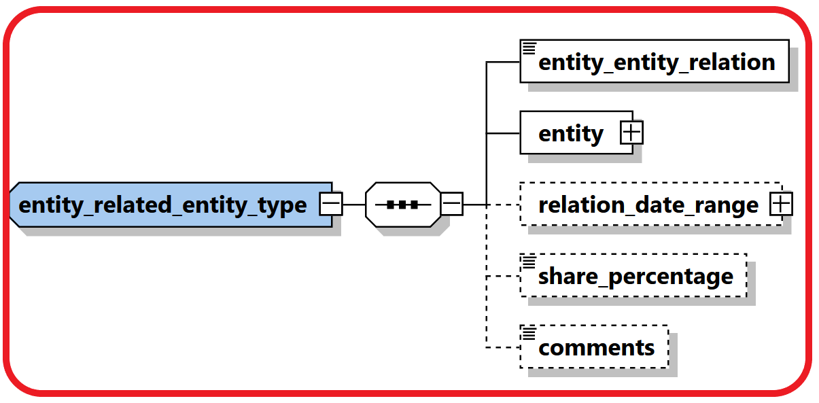

entity_entity_  relation | Schema 5.0.1  App 5.0 | Describe the relation between the two and related entities. | enumeration | Y | 5.17 Entity-Entity Relation Type
entity |  | Subnode holding detailed information about the related entity. | type  t_entity | Y | See 4.31 Type t_entity
relation_date_range | Schema 5.0.1  App 5.0 | Subnode to describe the date range relation | Type “relation_data_range_type” | N
share_percentage | Schema 5.0.1  App 5.0 | Describes the percentage of shares held between the two entities, relation type determines who owns the shares. | Decimal  0>>100 | N
comments |  | Generic Comments | 8000 | N

4.2.4 Entity Identifications
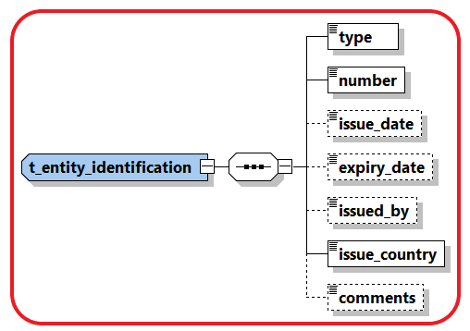

Name | Description | Length | Req. | Example
type | Document type | Enumeration | Y | 5.5 Identifier type
number | ID of the identification document | 255 | Y | AT08154711
issue_date | Identification document issue date | DateTime | N | 2001-12-17T09:30:47
expiry_date | Identification document expiry date | DateTime | N | 2012-01-01T00:00:00
issued_by | Name of Authority issued the document | 255 | N | Interior Ministry
issue_country | Country where the document was issued | Enumeration | Y | See 5.14 Country Codes
comments | Generic comments field | 8000 | N

4.3.1 Type t_person_my_client/t_person

The structure of these 2 types is exactly the same, it is introduced just to allow more restrictions when the person is a customer of the reporting entity in comparison to a person which is the customer of another reporting entity. i.e., some nodes which are not mandatory in t_person can be set mandatory in t_person_my_client.

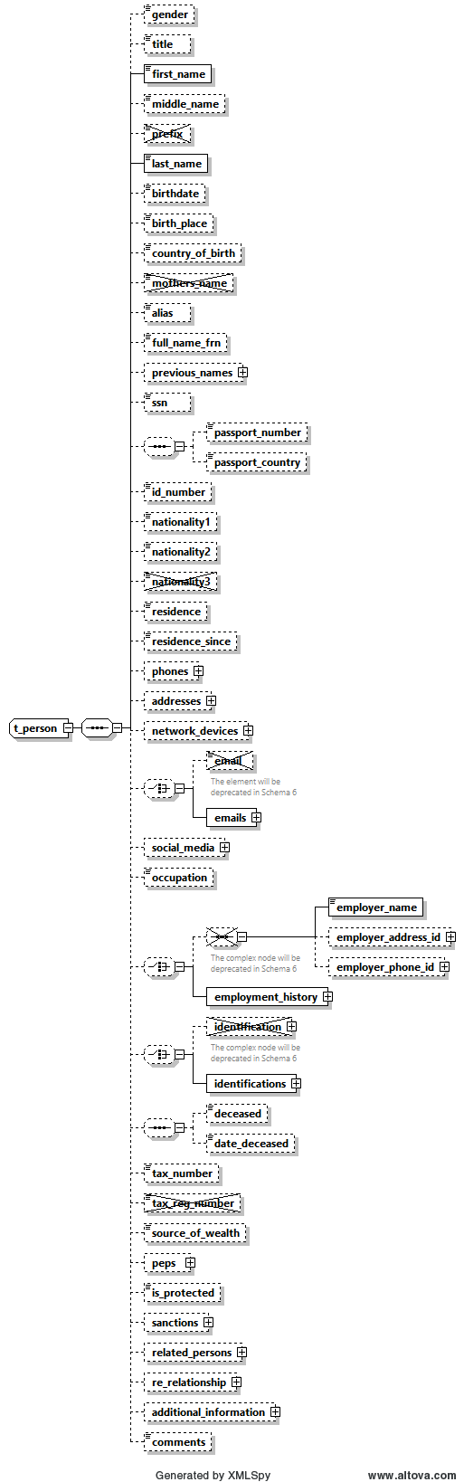
Figure 7: Overview type t_person
Name |  |  |  | #Schema  #App |  |  |  |  | Description |  |  |  | Length |  |  | Req. |  | Example
gender |  |  |  |  |  |  |  |  | Gender |  |  |  | Enumeration |  |  | N |  | M or F
title |  |  |  |  |  |  |  |  | Title |  |  |  | 30 |  |  | N |  | Dr.
first_name |  |  |  |  |  |  |  |  | First name |  |  |  | 100 |  |  | Y |  | Elias
middle_name |  |  |  |  |  |  |  |  | Middle name |  |  |  | 100 |  |  | N |  | X.
Prefix |  |  |  |  |  |  |  |  | Not in use
last_name |  |  |  |  |  |  |  |  | Last name |  |  |  | 100 |  |  | Y |  | Maschera
birthdate |  |  |  |  |  |  |  |  | Birth date |  |  |  | DateTime |  |  | N |  | 1953-01-25T00:00:00
birth_place |  |  |  |  |  |  |  |  | Place of birth |  |  |  | 255 |  |  | N |  | Vienna
country_of_birth |  |  |  | Schema 5.0.1  App 5.2 |  |  |  |  | Country of Birth |  |  |  | Enumeration |  |  | N |  | UN
mothers_name |  |  |  |  |  |  |  |  | Not in use
Alias |  |  |  |  |  |  |  |  | Alias Name, Known as, ..etc. |  |  |  | 100 |  |  | N
full_name_frn |  |  |  | Schema 5.0.1  App 5.2 |  |  |  |  | Foreign language Full name. |  |  |  | 255 |  |  | N
previous_names |  |  |  | Schema 5.0.1  App 5.2 |  |  |  |  | multi-occurrence node which will allow reporting a list of previous names for the person. |  |  |  | Subnode |  |  | N |  | 4.3.2 Type Previous Names
SSN |  |  |  |  |  |  |  |  | Social Security Number/Identification number |  |  |  |  |  |  | N |  | National ID Number
passport_number |  |  |  |  |  |  |  |  | No. of passport |  |  |  | 25 |  |  | N |  | Passport num to be used as unification rule
passport_country |  |  |  |  |  |  |  |  | Passport issue country  (Can be reported only when there is a passport number) |  |  |  | 25 |  |  | N |  | Passport country to be used as unification rule
id_ number |  |  |  |  |  |  |  |  | Any additional identification number rather then ssn and passport |  |  |  | 25 |  |  | N |  | Additional identification number
Nationality1 |  |  |  |  |  |  |  |  | Country of Nationality (1) |  |  |  | Enumeration |  |  | N |  | See 5.14 Country Codes
Nationality2 |  |  |  |  |  |  |  |  | Country of Nationality (2) |  |  |  | Enumeration |  |  | N |  | See 5.14 Country Codes
Nationality3 |  |  |  |  |  |  |  |  | Not in use
residence |  |  |  |  |  |  |  |  | Country of residence |  |  |  | Enumeration |  |  | N |  | See 5.14 Country Codes
residence_since |  |  |  | Schema 5.0.1  App 5.2 |  |  |  |  | when the person has a resident status in the relevant country |  |  |  | DateTime |  |  | N
Phones |  |  |  |  |  |  |  |  | A Holder node for a 1..many Phones |  |  |  |  |  |  | N
 |  |  | Phone |  |  |  |  |  |  |  | One occurrence of phone node |  |  | Type t_phone |  |  | N |  |  |  | See 4.6 Type t_phone
Addresses |  |  |  |  |  |  |  |  | A Holder node for a 1..many Addresses |  |  |  |  |  |  | N
 |  |  | Address |  |  |  |  |  |  |  | One occurrence of address node |  |  | Type t_address |  |  | N |  |  |  | 4.5 Type t_address
network_devices |  |  |  | Schema 5.0.1  App 5.2 |  |  |  |  | Not in use
 | Email |  |  |  |  |  |  |  | Email address |  |  | Type email_address  (255) |  |  |  |  |  | N | test@mail.com
 | emails |  |  |  |  | Schema 5.0.1  App 5.2 |  |  | supports several emails for the reported person in comparison with currently fix 5 emails |  |  | email_address (255) |  |  |  |  |  | N
social_media |  |  |  | Schema 5.0.1  App 5.2 |  |  |  |  | optional 1-many relations to report various social accounts |  |  |  | Subnode |  |  | N |  | 4.3.3 Type Social Account
Occupation |  |  |  |  |  |  |  |  | Occupation |  |  |  | 255 |  |  | N |  | Financial Analyst
 |  | employer_name |  |  |  |  |  |  |  | Employer’s name |  |  |  |  | 255 |  |  | N |  | FIC
 |  | employer_address_id |  |  |  |  |  |  |  | Employer’s address |  |  |  |  | type t_address |  |  | N |  | 4.5 Type t_address
 |  | employer_phone_id |  |  |  |  |  |  |  | Employer’s phone |  |  |  |  | type t_phone |  |  | N |  | See 4.6 Type t_phone
 |  | Employment History |  |  |  |  | Schema 5.0.1  App 5.2 |  |  | Supports many occurrences of employment information. Previous employment elements will be deprecated in future schemas |  |  |  |  | Subnode |  |  | N |  | 4.3.4 Type Employment History
 |  | identification |  |  |  |  |  |  | Subnode(s) for identification documents |  |  |  |  |  | subnode |  |  | N |  | See 4.8 Type t_person_identification
 |  | Identifications |  |  | Schema 5.0.1  App 5.2 |  |  |  | Allows deprecating the current repeated root level Identification node with a parent cover node Identifications with many occurrences of single Identification element |  |  |  |  |  | subnode |  |  | N |  | 4.3.5 Type t_person_identification
deceased |  |  |  |  |  |  |  |  | A Boolean to indicated if person has passed away |  |  |  | Boolean |  |  | N
deceased_date |  |  |  |  |  |  |  |  | If deceased, then RE can report deceased date if known as well |  |  |  | Date |  |  | N
tax_numebr |  |  |  |  |  |  |  |  | The person tax number |  |  |  | 100 |  |  | N
tax_reg_numebr |  |  |  |  |  |  |  |  | Not in use
source_of_wealth |  |  |  |  |  |  |  |  | Free text description of the person source of wealth |  |  |  | 255 |  |  | N
peps |  |  |  | Schema 5.0.1  App 5.2 |  |  |  |  | REs will be able to indicate if the reported person is a Politically Exposed Person with few additional attributes |  |  |  | Subnode |  |  | N |  | 4.3.6 Type PEPS
is_protected |  |  |  | Schema 5.0.1  App 5.2 |  |  |  |  | can be used for example to avoid disseminating protected subjects – goAML will just maintain the field. FICs must decide on how to use |  |  |  | Boolean |  |  | N
sanctions |  |  |  | Schema 5.0.1  App 5.2 |  |  |  |  | supports multi occurrence of “sanction list”. |  |  |  | Subnode |  |  | N |  | 4.14 Sanctions Node
related_persons |  |  |  | Schema 5.0.1  App 5.2 |  |  |  |  | An optional multiple relation sub node between a reported person and his/her social network. |  |  |  | Subnode |  |  | N |  | 4.3.7 Type Person Related Persons
business relationship |  |  |  | Schema 5.0.1  App 5.2 |  |  |  |  | host the starting and dates of the relationship between the Reporting Entity and the Person |  |  |  | Subnode |  |  | N |  | 4.12 Business Relationship
additional_  information |  |  |  | Schema 5.0.1  App 5.2 |  |  |  |  | A new optional generic node for adding any unplanned extra information. See dedicated section. |  |  |  | SubNode |  |  | N |  | 4.13 Additional Information
comments |  |  |  |  |  |  |  |  | Generic comments field |  |  |  | 8000 |  |  | N
Table 7: Details type t_person
Note: While submitting the report either Passport Number or ID Number or both should be provided

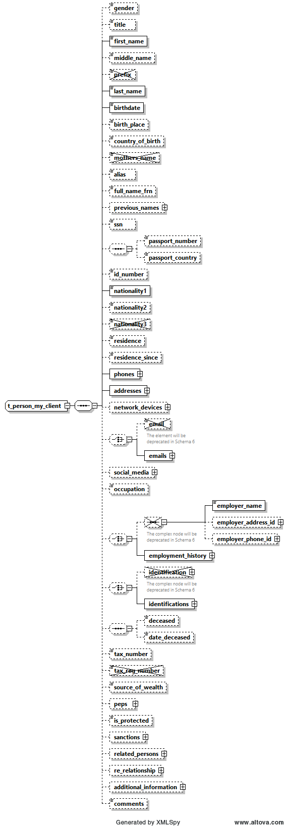
Figure 8: Overview type t_person_MyClient
Name |  |  |  | #Schema  #App |  |  |  |  | Description |  |  |  | Length |  |  | Req. |  | Example
gender |  |  |  |  |  |  |  |  | Gender |  |  |  | Enumeration |  |  | N |  | M or F
title |  |  |  |  |  |  |  |  | Title |  |  |  | 30 |  |  | N |  | Dr.
first_name |  |  |  |  |  |  |  |  | First name |  |  |  | 100 |  |  | Y |  | Elias
middle_name |  |  |  |  |  |  |  |  | Middle name |  |  |  | 100 |  |  | N |  | X.
Prefix |  |  |  |  |  |  |  |  | Not in use
last_name |  |  |  |  |  |  |  |  | Last name |  |  |  | 100 |  |  | Y |  | Maschera
birthdate |  |  |  |  |  |  |  |  | Birth date |  |  |  | DateTime |  |  | Y |  | 1953-01-25T00:00:00
birth_place |  |  |  |  |  |  |  |  | Place of birth |  |  |  | 255 |  |  | N |  | Vienna
country_of_birth |  |  |  | Schema 5.0.1  App 5.2 |  |  |  |  | Country of Birth |  |  |  | Enumeration |  |  | N |  | UN
mothers_name |  |  |  |  |  |  |  |  | Not in use
Alias |  |  |  |  |  |  |  |  | Alias Name, Known as, ..etc. |  |  |  | 100 |  |  | N
full_name_frn |  |  |  | Schema 5.0.1  App 5.2 |  |  |  |  | Foreign language Full name. |  |  |  | 255 |  |  | N
previous_names |  |  |  | Schema 5.0.1  App 5.2 |  |  |  |  | multi-occurrence node which will allow reporting a list of previous names for the person. |  |  |  | Subnode |  |  | N |  | 4.3.2 Type Previous Names
SSN |  |  |  |  |  |  |  |  | Social Security Number |  |  |  |  |  |  | N |  | National ID Number
passport_number |  |  |  |  |  |  |  |  | No. of passport |  |  |  | 25 |  |  | N |  | Passport num to be used as unification rule
passport_country |  |  |  |  |  |  |  |  | Passport issue country  (Can be reported only when there is a passport number) |  |  |  | 25 |  |  | N |  | Passport country to be used as unification rule
id_ number |  |  |  |  |  |  |  |  | Any additional identification number rather then ssn and passport |  |  |  | 25 |  |  | N |  | Additional identification number
Nationality1 |  |  |  |  |  |  |  |  | Country of Nationality (1) |  |  |  | Enumeration |  |  | Y |  | See 5.14 Country Codes
Nationality2 |  |  |  |  |  |  |  |  | Country of Nationality (2) |  |  |  | Enumeration |  |  | N |  | See 5.14 Country Codes
Nationality3 |  |  |  |  |  |  |  |  | Not in use
residence |  |  |  |  |  |  |  |  | Country of residence |  |  |  | Enumeration |  |  | N |  | See 5.14 Country Codes
residence_since |  |  |  | Schema 5.0.1  App 5.2 |  |  |  |  | when the person has a resident status in the relevant country |  |  |  | DateTime |  |  | N
Phones |  |  |  |  |  |  |  |  | A Holder node for a 1..many Phones |  |  |  |  |  |  | N
 |  |  | Phone |  |  |  |  |  |  |  | One occurrence of phone node |  |  | Type t_phone |  |  | Y |  |  |  | See 4.6 Type t_phone
Addresses |  |  |  |  |  |  |  |  | A Holder node for a 1..many Addresses |  |  |  |  |  |  | N
 |  |  | Address |  |  |  |  |  |  |  | One occurrence of address node |  |  | Type t_address |  |  | Y |  |  |  | 4.5 Type t_address
network_devices |  |  |  | Schema 5.0.1  App 5.2
 | Email |  |  |  |  |  |  |  | Not in use |  |  | Type email_address  (255) |  |  |  |  |  | N | test@mail.com
 | emails |  |  |  |  | Schema 5.0.1  App 5.2 |  |  | supports several emails for the reported person in comparison with currently fix 5 emails |  |  | email_address (255) |  |  |  |  |  | N
social_media |  |  |  | Schema 5.0.1  App 5.2 |  |  |  |  | optional 1-many relations to report various social accounts |  |  |  | Subnode |  |  | N |  | 4.3.3 Type Social Account
Occupation |  |  |  |  |  |  |  |  | Occupation |  |  |  | 255 |  |  | N |  | Financial Analyst
 |  | employer_name |  |  |  |  |  |  |  | Employer’s name |  |  |  |  | 255 |  |  | N |  | FIC
 |  | employer_address_id |  |  |  |  |  |  |  | Employer’s address |  |  |  |  | type t_address |  |  | N |  | 4.5 Type t_address
 |  | employer_phone_id |  |  |  |  |  |  |  | Employer’s phone |  |  |  |  | type t_phone |  |  | N |  | See 4.6 Type t_phone
 |  | Employment History |  |  |  |  | Schema 5.0.1  App 5.2 |  |  | Supports many occurrences of employment information. Previous employment elements will be deprecated in future schemas |  |  |  |  | Subnode |  |  | N |  | 4.3.4 Type Employment History
 |  | identification |  |  |  |  |  |  | Subnode(s) for identification documents |  |  |  |  |  | subnode |  |  | N |  | See 4.8 Type t_person_identification
 |  | Identifications |  |  | Schema 5.0.1  App 5.2 |  |  |  | Allows deprecating the current repeated root level Identification node with a parent cover node Identifications with many occurrences of single Identification element |  |  |  |  |  | subnode |  |  | N |  | 4.3.5 Type t_person_identification
deceased |  |  |  |  |  |  |  |  | A Boolean to indicated if person has passed away |  |  |  | Boolean |  |  | N
deceased_date |  |  |  |  |  |  |  |  | If deceased, then RE can report deceased date if known as well |  |  |  | Date |  |  | N
tax_numebr |  |  |  |  |  |  |  |  | The person tax number |  |  |  | 100 |  |  | N
tax_reg_numebr |  |  |  |  |  |  |  |  | Not in use
source_of_wealth |  |  |  |  |  |  |  |  | Free text description of the person source of wealth |  |  |  | 255 |  |  | N
peps |  |  |  | Schema 5.0.1  App 5.2 |  |  |  |  | REs will be able to indicate if the reported person is a Politically Exposed Person with few additional attributes |  |  |  | Subnode |  |  | N |  | 4.3.6 Type PEPS
is_protected |  |  |  | Schema 5.0.1  App 5.2 |  |  |  |  | can be used for example to avoid disseminating protected subjects – goAML will just maintain the field. FICs must decide on how to use |  |  |  | Boolean |  |  | N
sanctions |  |  |  | Schema 5.0.1  App 5.2 |  |  |  |  | supports multi occurrence of “sanction list”. |  |  |  | Subnode |  |  | N |  | 4.14 Sanctions Node
related_persons |  |  |  | Schema 5.0.1  App 5.2 |  |  |  |  | An optional multiple relation sub node between a reported person and his/her social network. |  |  |  | Subnode |  |  | N |  | 4.3.7 Type Person Related Persons
business relationship |  |  |  | Schema 5.0.1  App 5.2 |  |  |  |  | host the starting and dates of the relationship between the Reporting Entity and the Person |  |  |  | Subnode |  |  | N |  | 4.12 Business Relationship
additional_  information |  |  |  | Schema 5.0.1  App 5.2 |  |  |  |  | A new optional generic node for adding any unplanned extra information. See dedicated section. |  |  |  | SubNode |  |  | N |  | 4.13 Additional Information
comments |  |  |  |  |  |  |  |  | Generic comments field |  |  |  | 8000 |  |  | N
Table 8: T_Person My_Client
Note: While submitting the report either Passport Number or ID Number or both should be provided

4.3.2 Type Previous Names
It allows reporting a list of previous names for the person. Each Name contains First and Last Name in addition to a comments field to provide the context.
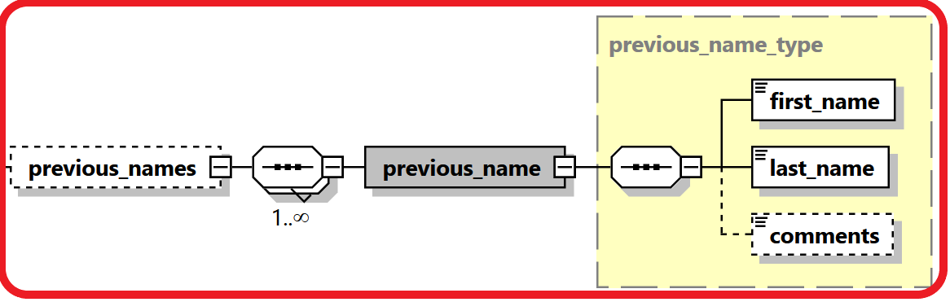

Name | #Schema  #App | Description | Length | Req. | Example
First_name | Schema 5.0.1  App 5.2 | First Name | 100 | Y
last_name | Schema 5.0.1  App 5.2 | Last Name | 100 | Y
comments | Schema 5.0.1  App 5.2 | Generic Comments | Comments Type | N

4.3.3 Type Social Account

REs can report social media accounts of the reported person.
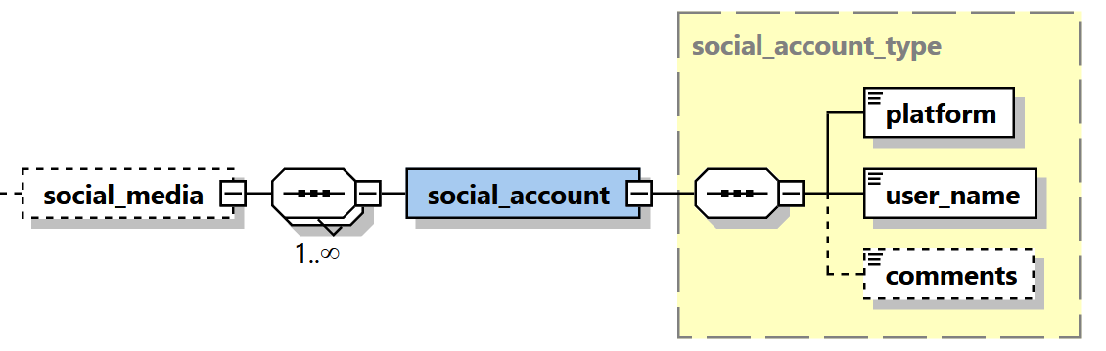

Name | #Schema  #App | Description | Length | Req. | Example
platform | Schema 5.0.1  App 5.2 | Name of social media platform | 255 | Y
user_name | Schema 5.0.1  App 5.2 | User Name in that social media platform | 255 | Y
comments | Schema 5.0.1  App 5.2 | Description of the function held by the PEP. | Comments type | N

4.3.4 Type Employment History
Reporting entities can report many occurrences of employment information including employer name, business, identification, phones, addresses and employment date range.
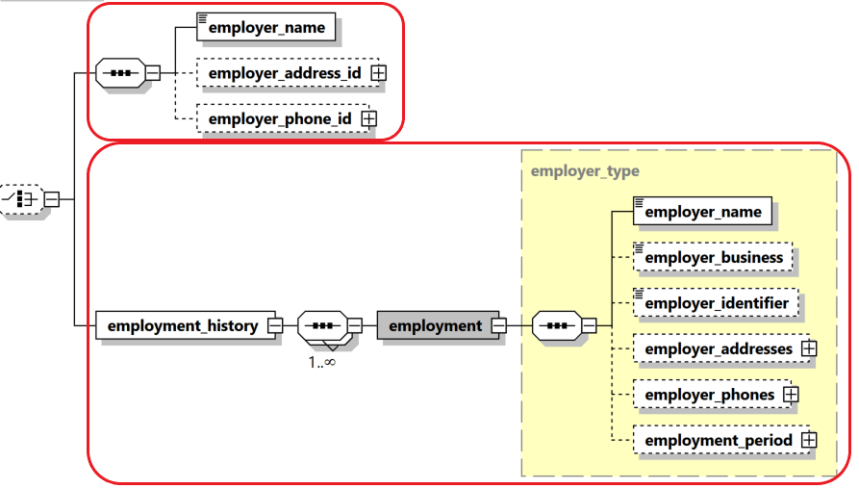

Name | #Schema  #App | Description | Length | Req. | Example
employer_name | Schema 5.0.1  App 5.2 | Type of relation | Enumeration | N
Person | Schema 5.0.1  App 5.2 | Person node | Subnode | N | See 4.3.1 Type t_person_my_client/ t_person
relation_date_range | Schema 5.0.1  App 5.2 | The time frame of the relation between the two persons. | Subnode | N | 4.10 Relation Date Range Type
comments | Schema 5.0.1  App 5.2 | Description of the function held by the PEP. | Comments type | N

4.3.5 Type t_person_identification
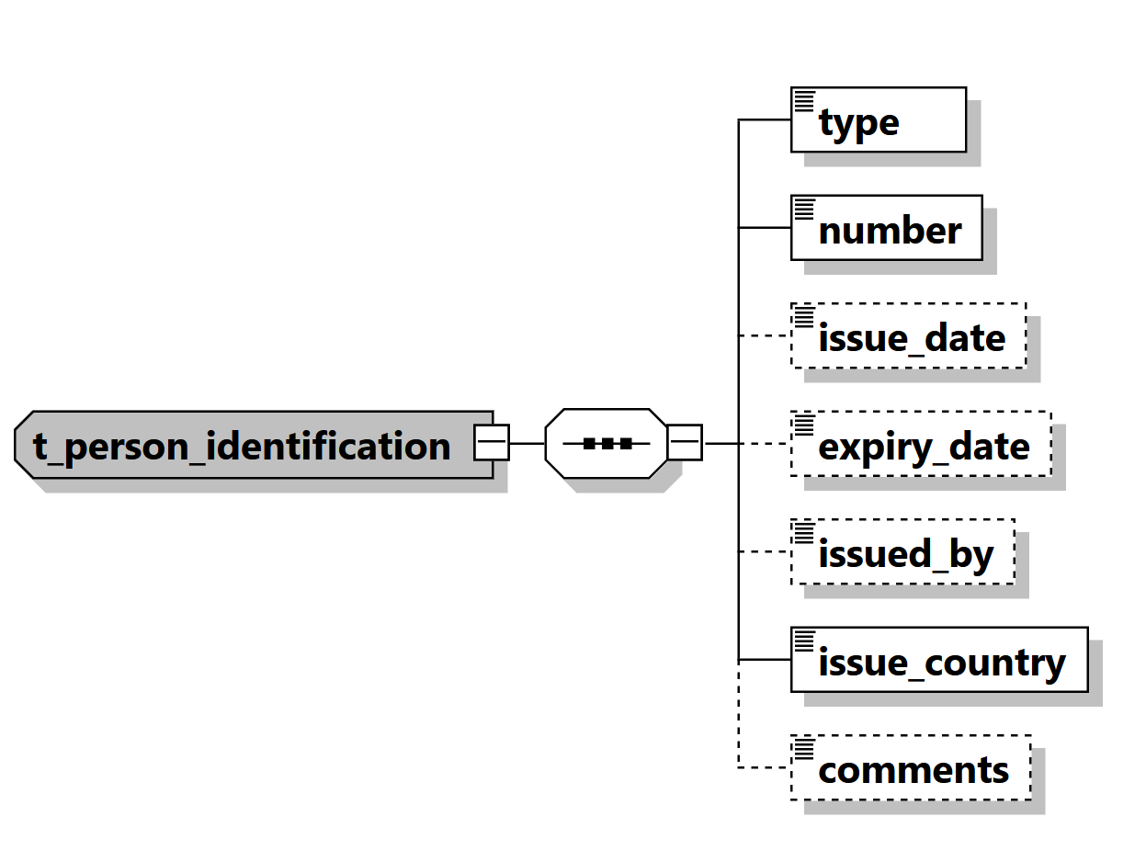

Figure 20: Overview type t_person_identification

Name | Description | Length | Req. | Example
type | Document type | Enumeration | Y | 5.5 Identifier type
number | ID of the identification document | 255 | Y | AT08154711
issue_date | Identification document issue date | DateTime | N | 2001-12-17T09:30:47
expiry_date | Identification document expiry date | DateTime | N | 2012-01-01T00:00:00
issued_by | Name of Authority issued the document | 255 | N | Interior Ministry
issue_country | Country where the document was issued | Enumeration | Y | See 5.14 Country Codes
comments | Generic comments field | 8000 | N
Table 20: Type t_person_identification

4.3.6 Type PEPS
Reporting entities can indicate if the reported person is/was a Politically Exposed Person with few additional attributes, like country, function name, function description, date range and general comments. Multiple occurrences of PEP info per person is supported as well.
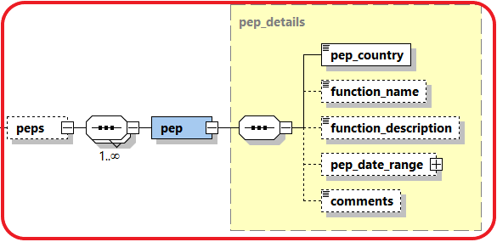

Name | #Schema  #App | Description | Length | Req. | Example
pep_country | Schema 5.0.1  App 5.2 | Name of the related country | Enumeration | Y
function_name | Schema 5.0.1  App 5.2 | Name of the function held by the PEP. | 255 | N
function_description | Schema 5.0.1  App 5.2 | Description of the function held by the PEP. | Comments type | N
pep_date_range | Schema 5.0.1  App 5.2 | The time frame of the subject being PEP in this occurrence. | Subnode | N | 4.10 Relation Date Range Type
comments | Schema 5.0.1  App 5.2 | Generic Comments | Comments Type | N

4.3.7 Type Person Related Persons
Reporting entities can report social network of the reported person
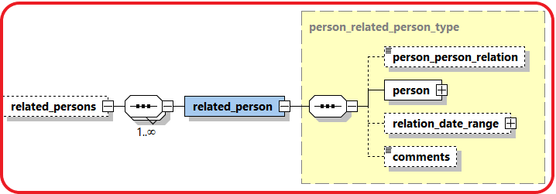

Name | #Schema  #App | Description | Length | Req. | Example
person_person_  relation | Schema 5.0.1  App 5.2 | Type of relation | Enumeration | N | 5.23 Person-Person Relation Type
Person | Schema 5.0.1  App 5.2 | Person node | Subnode | N | 4.3.1 Type t_person_my_client/ t_person
relation_date_range | Schema 5.0.1  App 5.2 | The time frame of the relation between the two persons. | Subnode | N | 4.10 Relation Date Range Type
comments | Schema 5.0.1  App 5.2 | Description of the function held by the PEP. | Comments type | N

4.4.1 Type t_person_registration_in_report
The structure of this type is similar to that of type t_person, but dedicated to the reporting person details.

4.4.2 Type t_conductor/t_conductor_my_client
The structure of these types is similar to that of type t_person, but dedicated to the conductor person details,

4.5 Type t_address
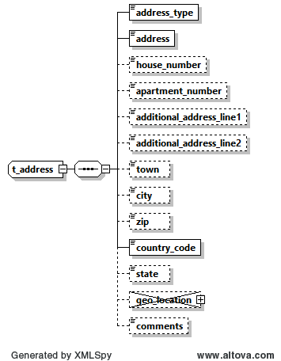

Figure 10: Overview type t_address

Name | #Schema  #App |  | Description | Length | Req. | Example
Address_type |  |  | The contact type of the address | Enumeration | Y | Private, Business,..  See 5.9 Contact Type
Address |  |  |  | 100 | Y | -
house_number | Schema 5.0.1  App 5.2
apartment_number | Schema 5.0.1  App 5.2
additional_address_line1 | Schema 5.0.1  App 5.2 |  | Additional Address line 1 | 100 | N
additional_address_line2 | Schema 5.0.1  App 5.2
Town |  |  | Name of Town/district/as part of a City | 255 | N
City |  |  | City/Province | 255 | N | -
Zip |  |  | Zip Code | 10 | N | A-1220
country_code |  |  | Country | Enumeration | Y | See 5.14 Country Codes
State |  |  | State | 255 | N
geo_location | Schema 5.0.1  App 5.2 |  | Not in use | Subnode | N
latitude |  | Schema 5.0.1  App 5.2 | Address latitude | Decimal  -90>>90 | N | 48.210033
longitude |  | Schema 5.0.1  App 5.2 | Address longitude | Decimal  -180>>180 | N | 16.363449
Plus Code |  | Schema 5.0.1  App 5.2 | Address “Plus Code” | 25 | N | 6CRP+R9
is_approx_location |  | Schema 5.0.1  App 5.2 | Is the location accurate? | Boolean | N | True
error_distance_margin |  | Schema 5.0.1  App 5.2 | Error margin | Decimal | N | 500
Margin_uom |  | Schema 5.0.1  App 5.2 | Unit of measurement for error | 255 | N | Meter
comments |  |  | Generic comments | 8000 | N
able 10: Details type t_address

4.6 Type t_phone
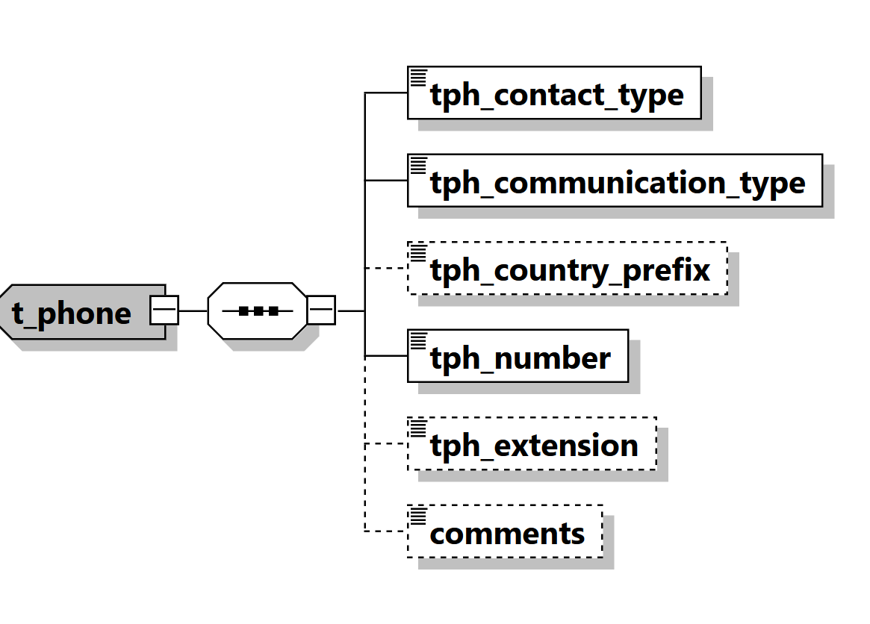
Figure 11: Overview type t_phone

Name | Description | Length | Req. | Example
tph_contact_type | The contact type of the Phone | Enumeration | Y | Private, Business,..  See 5.9 Contact Type
tph_communication_type | The comm.. type of the Phone | Enumeration | Y | Landline, mobile ,fax,..  5.10 Communication Type
tph_country_prefix | Country phone code | 4 | N | 0043
tph_number | Phone number | 50 | Y | 6655778
tph_extension | Phone’s extension | 10 | N | 7789
comments | Generic comments | 8000 | N

Table 11: Details type t_phone

4.7 Type t_foreign_currency

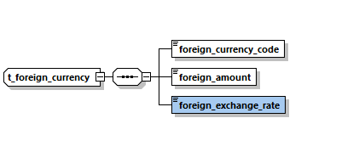
Figure 12: Overview type t_foreign_currency

Name | Description | Length | Req. | Example
foreign_currency_code | Currency Code according to ISO 4217 | Enumeration | Y | See 5.13 Currencies
foreign_amount | Transaction amount in foreign currency | Decimal | Y | 1300.50
foreign_exchange_rate | Exchange rate which has been used for transaction  Default is set as optional in Schema 5.0.2 | Decimal | Y | 1.45
Table 12: Details type t_foreign_currency

4.8 Type report_party_type

Introduced in schema 4.0 and enhanced in Schema 5. Represents an involved subject in a report and its details.
Subject can be a Person, an Account or an Entity together with its my_client – Only one of them can be included per involved party.

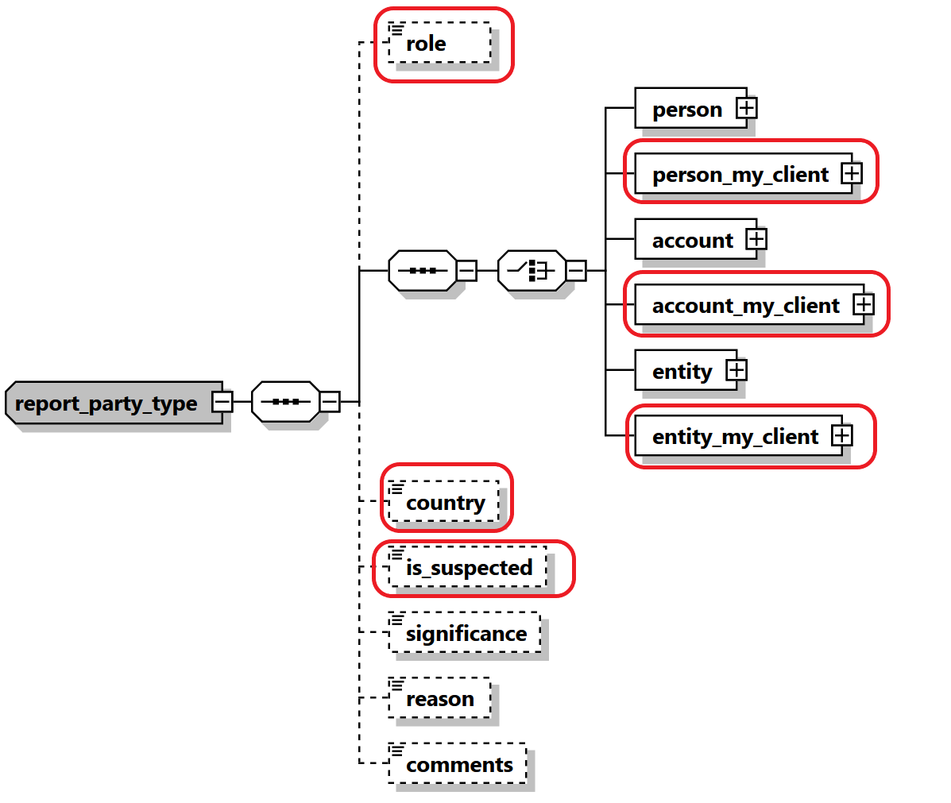
Figure 21: Overview type report_party_type

Name |  |  | #Schema  #App |  | Description |  | Length | Req. |  | Example
Role |  |  | Schema 5.0.1  App 5.2 |  | Role of Party in this activity |  | Enumeration | N |  | Conductor
 |  | One of the following subject nodes must be included when activity node is used
 | person |  |  |  |  | Represents an involved person node |  |  | t_person type |  | Y
 | person_my_client |  |  | Schema 5.0.1  App 5.2 |  | Represents an involved my_client person node |  |  | t_person_my_client type |  | Y
 | account |  |  |  |  | Represents an involved account |  |  | t_account type |  | Y
 | Account_my_client |  |  | Schema 5.0.1  App 5.2 |  | Represents an involved my_client account |  |  | t_account_my_client type |  | Y
 | entity |  |  |  |  | Represents an involved entity |  |  | t_entity type |  | Y
 | Entity_my_client |  |  | Schema 5.0.1  App 5.2 |  | Represents an involved my_client entity |  |  | t_entity_my_client type |  | Y
country |  |  | Schema 5.0.1  App 5.2 |  | The country of the reported party |  | Enumeration | N |  | UN
is_suspected |  |  | Schema 5.0.1  App 5.2 |  | Indicates if the party is suspected or not. |  | Boolean | N |  | True/False
significance |  |  |  |  | The significance of the subject in the report |  | Integer | N |  | 0 - 10
reason |  |  |  |  | Why the subject is involved in the current report |  | 8000 | N
comments |  |  |  |  | Generic comments element |  | 8000 | N
Table 21: Type report_party_type

4.9.1 Network Device Type

Describes additional information in virtual currency and mobile money transactions regarding the used device and related IP address. Allows Reporting Entities like ISP providers to report online connections of their clients if needed.
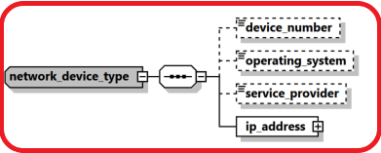

Name | #Schema  #App | Description | Length | Req. | Example
device_number | Schema 5.0.1  App 5.1 | The number of device to send/receive the money in transaction context | 50 | N | 06501234567
operating_system | Schema 5.0.1  App 5.1 | The device operating system | Enumeration | N | iOS, Android, Windows, Mac OS, Linux…
service_provider | Schema 5.0.1  App 5.1 | The name of the service provider in case of mobile phone for example | 255 | N | Orange
ip_address | Schema 5.0.1  App 5.1 | Describes the details of the used “IP address” | Subnode | Y | See 4.8.2 IP Address Type

4.9.2 IP Address Type

Introduced in schema 5.0.1, the type is used in goAML Application 5.1 to describe IP address details of the transaction party.

The type will be used in goAML Application 5.2 to allow Reporting Entities like ISP providers to report online connections of their clients if needed.

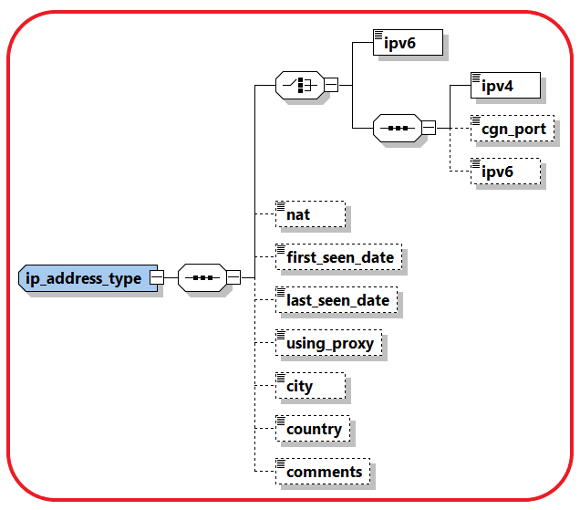

Name |  |  | #Schema  #App |  | Description |  |  | Length |  | Req. |  |  |  | Example
 | Ipv6 |  |  | Schema 5.0.1  App 5.1 |  | IP address in IPV6 format |  | 45 |  |  | Y | 2001:0db8:85a3:0000:  0000:8a2e:0370:7334
 | Ipv4 |  |  | Schema 5.0.1  App 5.1 |  | IP address in IPV4 format |  | 15 |  |  | Y | 172.31.255.255
 |  | cgn_port |  |  | Schema 5.0.1  App 5.1 |  | CGN Port |  | Integer |  |  |  | N |  | 44
 |  | Ipv6 |  |  | Schema 5.0.1  App 5.1 |  | IP address in IPV6 format, can be reported optionally if the main format is ipv4 |  | 45 |  |  |  | Y |  | 2001:0db8:85a3:0000:  0000:8a2e:0370:7334
Nat |  |  | Schema 5.0.1  App 5.1 |  | network address translation |  |  | 15 |  | N |  |  |  | 1.1.1.1
first_seen_date |  |  | Schema 5.0.1  App 5.1 |  | First time IP address is reported |  |  | DateTime |  | N
last_seen_date |  |  | Schema 5.0.1  App 5.1 |  | Last time IP address is reported |  |  | DateTime |  | N
using_proxy |  |  | Schema 5.0.1  App 5.1 |  | A flag to indicate if Proxy was used |  |  | Boolean |  | N |  |  |  | True/False
City |  |  | Schema 5.0.1  App 5.1 |  | City name |  |  | 255 |  | N
Country |  |  | Schema 5.0.1  App 5.1 |  | Country code |  |  | Enum |  | N
Comments |  |  | Schema 5.0.1  App 5.1 |  | Generic Comments |  |  | 8000 |  | N

4.10 Relation Date Range Type

A new type describing relations date range was introduced and is used now with each relation between two nodes in goAML schema. The type is used gradually with each goAML release since 5.0 in combination with implementing the parent type. The Booleans are considered false by default if not reported.
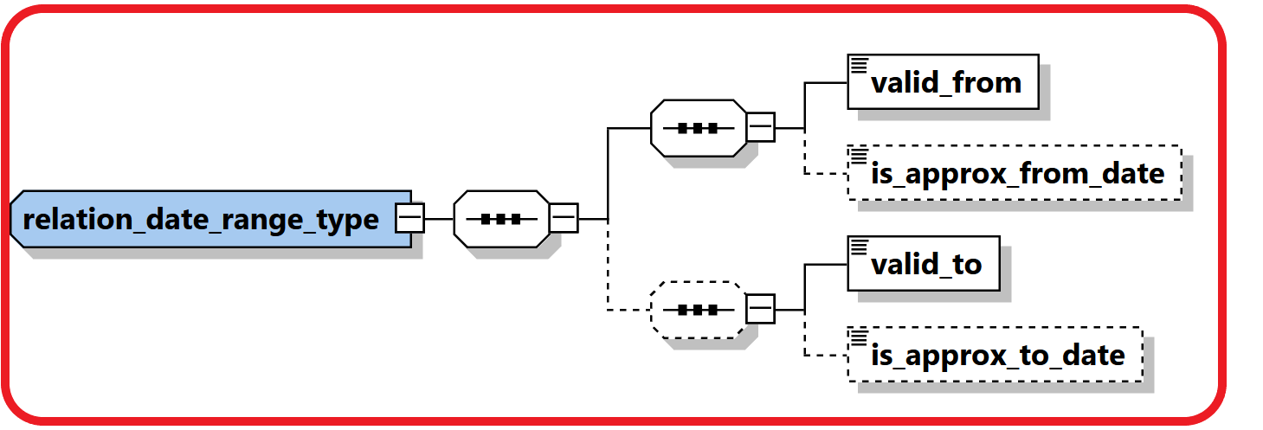

Name | #Schema  #App | Description | Length | Req. | Example
valid_from | Schema 5.0.1  App 5.1 | Valid FROM date | DateTime | Y
is_approx_from_date | Schema 5.0.1  App 5.1 | Is the “Valid From Date” accurate? | Boolean | N
valid_to | Schema 5.0.1  App 5.1 | Valid TO Date | DateTime | Y
is_approx_to_date | Schema 5.0.1  App 5.1 | Is the “Valid To Date” accurate? | Boolean | N

4.11 Comments Type
A new comment_type was introduced with max length of 8000 chars instead of 4000 as newer versions of SQL server supports longer length now. All elements like Comments, Reason, Action and Description elements all over the schema are defined now using the new type.

4.12 Business Relationship
A new subnode was introduced to describe the relation between the reported subjects and the reporting entity, including information regarding the relation type and timeframe. Person and Entities in goAML can have multiple relationships with different reporting entities.

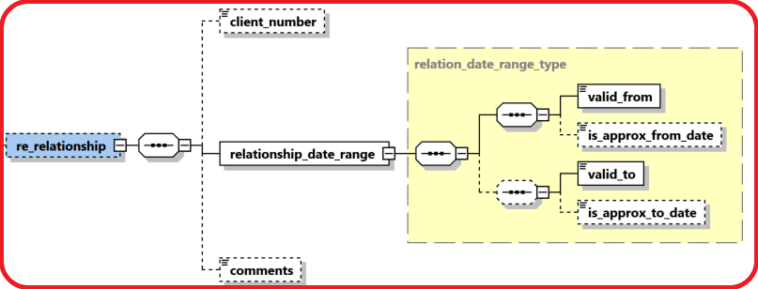

Name | #Schema  #App | Description | Length | Req. | Example
client_number | Schema 5.0.1  App 5.2 | A reference number of the customer at the RE side | 255 | N
valid_from | Schema 5.0.1  App 5.2 | Valid FROM date | DateTime | Y
is_approx_from_date | Schema 5.0.1  App 5.2 | Is the “Valid From Date” accurate? | Boolean | N
valid_to | Schema 5.0.1  App 5.2 | Valid TO Date | DateTime | Y
is_approx_to_date | Schema 5.0.1  App 5.2 | Is the “Valid To Date” accurate? | Boolean | N
comments | Schema 5.0.1  App 5.2 | Generic Comments | Comments Type | N

4.13 Additional Information

A new optional generic node for adding any number of unplanned extra information in a controlled way.
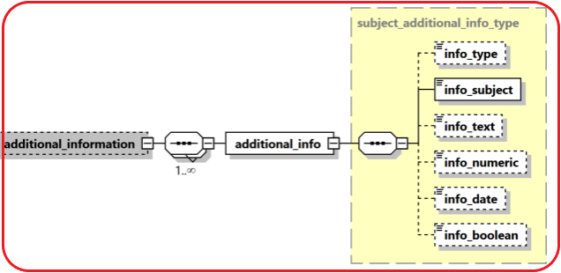

Name | #Schema  #App | Description | Length | Req. | Example
info_type | Schema 5.0.1  App 5.2 | Type of the provided info | Enumeration | N
Subject | Schema 5.0.1  App 5.2 | Short description of the additional info | 255 | Y
Info_text | Schema 5.0.1  App 5.2 | A text value of the provided info | Comments type | N
Info_numeric | Schema 5.0.1  App 5.2 | A numeric value of the provided info | decimal | N
info_date | Schema 5.0.1  App 5.2 | A date value of the provided info | Date Time | N
Info_boolean | Schema 5.0.1  App 5.2 | A Boolean value of the provided info | Boolean | N

4.14 Sanctions Node
New sanctions node was added which supports multi occurrence of “sanction list”. Each Sanction list contains several details about the list like providing source, list name, matching criteria, date of joining/exiting a list, .etc.
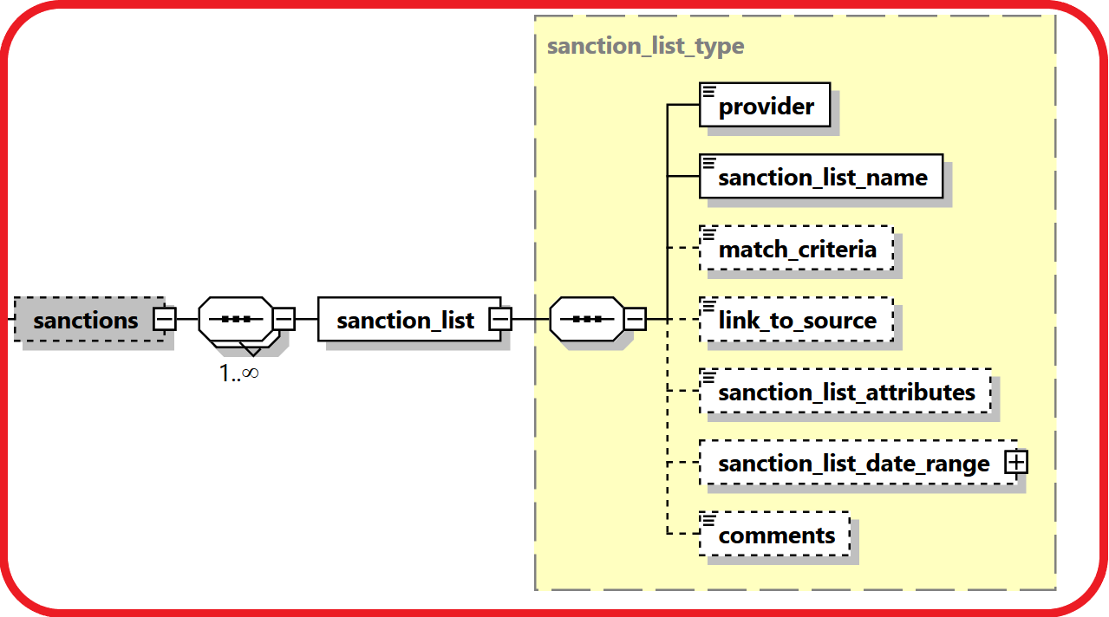

Name | #Schema  #App | Description | Length | Req. | Example
Provider | Schema 5.0.1  App 5.2 | Name of the sanctions list provider | 255 | N
sanctions_list_name | Schema 5.0.1  App 5.2 | Name of the sanctions list | 255 | Y
match_criteria | Schema 5.0.1  App 5.2 | The criteria used by the RE to match the reported subject with the name in the list. | Comments type | N
link_to_source | Schema 5.0.1  App 5.2 | A link to the subject in the sanction list document | 255 | N
sanctions_list_attributes | Schema 5.0.1  App 5.2 | Any additional info regarding the subject provided in the sanction list document | Comments type | N
Sanctions_list_date_range | Schema 5.0.1  App 5.2 | The time frame of the subject existence in the list | Subnode | N | 4.10 Relation Date Range Type
comments | Schema 5.0.1  App 5.2 | Generic Comments | Comments Type | N

4.15 Means of Transportation Node

A new complex node to capture customs related reports where subjects carry money cross borders as well as possible Trade Based Money Laundering reporting. The node supports multi routes per transaction with details regarding the reported point, transportation mode (Air, Sea, Road, Train, ..etc.), transportation type (Comm. Airline, Private Jet, Vessel, Cruise Ship, Car, Bus, ..etc.), then step direction, status, date, carrier details as well location details of each route.
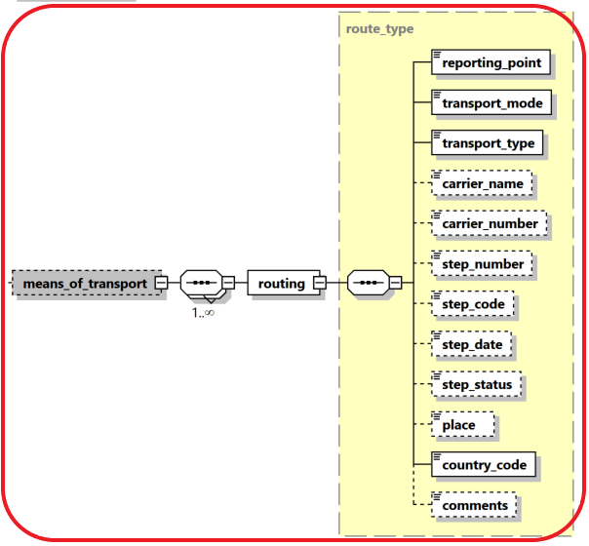

Name | #Schema  #App | Description | Length | Req. | Example
reporting_point | Schema 5.0.1  App 5.2 | Is the report if from this route step? | Boolean | N
transport_mode | Schema 5.0.1  App 5.2 | Transportation mode | Enumeration | Y | Air, Sea, Road, Train,
transport_type | Schema 5.0.1  App 5.2 | Transportation Type | Enumeration | Y | Comm. Airline, Private Jet, Vessel, Cruise Ship, Car, Bus
carrier_name | Schema 5.0.1  App 5.2 | Name of Carrier | 255 | N | UN Airline
carrier_number | Schema 5.0.1  App 5.2 | Number of Carrier | 255 | N | UN123
step_number | Schema 5.0.1  App 5.2 | The number of this step in the route | Integer | N
step_code | Schema 5.0.1  App 5.2 | The code of the step | Enumeration | N | Start, End, Transit,..
step_date | Schema 5.0.1  App 5.2 | Date of the step | DateTime | N
step_status | Schema 5.0.1  App 5.2 | Status of the step | Enumeration | N | Conducted, Cancelled, ..
place | Schema 5.0.1  App 5.2 | Name of the Entry/Exit place | 255 | N | Name of Port, Airport, Border Cross, …
country_code | Schema 5.0.1  App 5.2 | Name of step country | Enumeration | Y
comments | Schema 5.0.1  App 5.2 | Generic Comments | Comments Type | N

Lookup Values

All schema lookups are defined as enumerations. goAML application includes an option to update the schema automatically with the lookup codes defined by the FIC in the “Lookup Master” screen. Reporting entities cannot submit reports with undefined lookup codes.

Most of the lookup enumerations mentioned below are just suggestions. Feel free to adjust them using “Lookup Master” screen.

5.1 Submission type
Value | Description
E | Electronically
M | Manually
Table 13: submission type

5.2 Funds type
* The following list is a suggestion. Actual codes defined by FIC in “Lookup Master” will be added automatically to the Schema by goAML client application.

Value | Description
BDFT | Bank Draft
BGNT | Bank Guarantee
BEXH | Bill of Exchange
CASH | Cash
CSN | Casino Chips
CHQ | Cheque
CDT | Credit
CC | Credit Card
CE | Currency Exchange
DB | Debit card
DPT | Deposit
ETN | Electronic Fund
FSF | Funds in Safe
GMCHP | Gaming Chips
SEC | Government Securities
LIP | Life Insurance Policy
LP | Loan
MR | Money remittance
OT | Other
PM | Precious Metals
PPC | Prepaid Card
PN | Promissory Note
RE | Real estate
SC | Securities
SHR | Shares
TCHQ | Traveller's Cheque
- | UNKNOWN
VC | Virtual Currency

Table 14: Funds type

5.3 Account type
*The following list is a suggestion. Actual codes defined by FIC in “Lookup Master” will be added automatically to the Schema by goAML client application.

Value | Description
BUS | Business
CAP | Capital Payment Account
COM | Commodity Account
CCA | Credit Card Account
CUR | Current Account
CUS | Custody Account
DCA | Debit Card Account
DIG | Digital wallet
GAM | Gaming Account
GUR | Guarantee Account
INS | Insurance Policy
INV | Investment account
LON | Loan Account
MBLW | Mobile wallet
MRT | Mortgage Account
OTR | Other
OTH | Other Type of Account
PAY | Payment account
PMA | Precious Metal Account
SDB | Safe Deposit Box
SVA | Saving Deposit Account
SEC | Securities Account
TECH | Technical Account
DEP | Term Fixed Deposit Account
TST | Trust
- | Unknown
VCW | Virtual Currency Wallet

Table 15: Account type

5.4 Account status type
*The following list is a suggestion. Actual codes defined by FIC in “Lookup Master” will be added automatically to the Schema by goAML client application.

Value | Description
A | Active
B | Blocked
C | Closed
D | Dormant
F | Frozen/Suspended
N | New
OTH | Other
S | Seized
- | UNKNOWN

Table 16: Account status type

5.5 Identifier type
*The following list is a suggestion. Actual codes defined by FIC in “Lookup Master” will be added automatically to the Schema by goAML client application.

Value | Description
D | Driver''s Licence
F | Foreign Identity Card
N | National Identification Card
P | Passport
RF | Refugee ID
R | Residence Permit
URC | UNHCR Refugee card
- | UNKNOWN

Table 17: Identifier type

5.6 Conduction/Transaction mode Type
*The following list is a suggestion. Actual codes defined by FIC in “Lookup Master” will be added automatically to the Schema by goAML client application.
Value | Description
AD | Agent Deposit
ATM | ATM
K | Cash
CRIER | Courier
CDT | Credit
CRDTC | Credit Card
CEX | Currency Exchange
DEBTC | Debit Card
ET | Electronic Funds Transfer
FRX | Forex Exchange
BRNVH | In Branch/Office
INTR | Internet/Web portal
LYFI | Life Insurency Policy
MAP | Mobile App
MM | Mobile Money
MR | Money Remittance
ONLIN | Online Order
OTR | Other
- | UNKNOWN
VC | Virtual Currency

Table 25: Conduction Type

5.7 Transaction Item Status
*The following list is a suggestion. Actual codes defined by FIC in “Lookup Master” will be added automatically to the Schema by goAML client application.
Value | Description
A | Bought
G | Destroyed
F | Donated
E | Exchanged
D | Hired
C | Let
H | Other
B | Sold
- | UNKNOWN

Table 26: Transaction Item Status

5.8 Report Code

Value | Description
AIFZ | Additional Information File(AIF)
CTR | Cash Transaction Report(CTR)
CBCD | Crossborder Cash/BNIs Declaration
IRD | Incoming Request for Information Domestic(IRD)
IRI | Incoming Request for Information International(IRII)
ORD | Outgoing Request for Information Domestic(ORID)
ORI | Outgoing Request for Information International(ORII)
RAIF | Response to Additional info File(RAIF)
RORD | Response to Outgoing Request Domesic(RORD)
RORI | Response to Outgoing request International(RORI)
RIRD | Response to the Incoming Request for Info Domestic
RIRII | Response to the Incoming Request Info International
SAR | Suspicious Activity Report (SAR)
STR | Suspicious Transaction Report(STR)
TF | Terrorist Activity/Financing Transaction Report
WTR | Wire Transfer Report(WTR)

Table 27: Report Code

5.9 Contact Type
*The following list is a suggestion. Actual codes defined by FIC in Lookup Master will be added automatically to the Schema by goAML client application.

Value | Description
B | Business
OTR | Other
P | Private
- | UNKNOWN

Table 28: Contact Type

5.10 Communication Type
*The following list is a suggestion. Actual codes defined by FIC in Lookup Master will be added automatically to the Schema by goAML client application.
Value | Description
1 | E-Mail
F | Fax
L | Landline Phone
M | Mobile Phone
OTR | Other
P | Pager
S | Satellite Phone
- | UNKNOWN

Table 29: Communication Type

5.11 Entity Legal Form Type
* The following list is a suggestion. Actual codes defined by FIC in “Lookup Master” will be added automatically to the Schema by goAML client application.

Value | Description
ASN | Association
CO | Charity Organization
CBF | Common Benefit Foundation
COO | Cooperative Society
FBO | Faith Based Organization
FML | Family Undertaking
FRN | Foreign Representative Office
FLP | Full Liability Partnership
RLG | Institution of Religious Organisation
INV | Investment Company
MBF | Mixed Benefit Foundation
MUC | Municipal Company
NGO | Non-Governmental Organization
NBO | Non-Profit Organization
PBF | Private Benefit Foundation
PLG | Private Limited by guarantee Company
PLSG | Private Limited by shares and Guarantee Company
PLS | Private Limited by shares Company
PLC | Public Limited Company
SPS | Sole Proprietorship
SOC | State-Owned Enterprise
ARB | Trade Union
TRUST | Trusts
- | Unknown

!Unexpected End of Formula
Table 30: Legal Form Type

5.12 Transaction Item Type
* The following list is a suggestion. Actual codes defined by FIC in “Lookup Master” will be added automatically to the Schema by goAML client application.

Code | Name
Cs | Consumer goods
E | Equipment
FRC | Foreign Currency
F | Furniture
G | Gold
IE | Industrial Equipment
INS | Insurance
IT | Intangible Asset
INT | Intellectual Property Rights
J | Jewellery
LND | Land
Art | Object of Art
OTR | Other
P | Property
RE | Real Estate
SE | Securities
SVS | Services
- | Unknown
V | Vehicle
W | Weapon

Table 31: Transaction Item Type

5.13 Currencies
World Currencies (and their abbreviations) listed by ISO 4217
Value | Description
XOX | 0x
AFN | Afghan afghani
DZD | Algerian Dinar
AOA | Angolan kwanza
ARS | Argentinean Nuevo Peso
AWG | Aruban Guilder
AUD | Australian Dollar
AZN | Azerbaijani manat
BSD | Bahamian Dollar
BHD | Bahraini Dinar
THB | Baht
PAB | Balboa
BBD | Barbados Dollar
BYR | Belarussian Rouble
BZD | Belize Dollar
BMD | Bermudian Dollar
XBT | Bitcoin
XAB | Bitcoin ABC
XTC | Bitcoin Cash
XTG | Bitcoin Gold
XBS | Bitcoin SV
BOB | Boliviano
BND | Brunei Dollar
BGN | Bulgarian lev
BIF | Burundi Franc
CAD | Canadian Dollar
KYD | Cayman Islands Dollar
CLP | Chilean Peso
XTS | Code reserved for testing purposes
COP | Colombian Peso
KMF | Comorian Franc
CDF | Congolese franc
BEC | Convertible Belgian Franc (no longer in use)
BAM | Convertible Mark
NIO | Cordoba oro
CRC | Costa Rican Colón
HRK | Croatian Kuna
CUP | Cuban Peso
CZK | Czech Koruna
GMD | Dalasi
DKK | Danish Krone
XDH | Dash
KPW | Democratic People's Republic of Korean Won
DJF | Djibouti Franc
STD | Dobra
DOP | Dominican Republic Peso
AMD | Dram
XCD | East Caribbean Dollar
EGP | Egyptian Pound
XES | EOS
ERN | Eritrean Nakfa
CVE | Escudo Caboverdiano
XET | Ethereum
XEC | Ethereum Classic
ETB | Ethiopian Birr
XTP | ETP
EUR | Euro (replacement name for the ECU)
XBA | European Composite Unit
XBB | European Monetary Unit
XBD | European Unit of Account 17
XBC | European Unit of Account 9
FKP | Falkland Pound
FJD | Fiji Dollar
BEL | Financial Belgian Franc (no longer in use)
HUF | Forint
XAF | Franc de la Communauté financière africaine
XPF | Franc des Comptoirs français du Pacifique
GHS | Ghanaian cedi
GIP | Gibraltar Pound
XAU | Gold
HTG | Gourde
PYG | Guarani
GNF | Guinean franc
GYD | Guyana Dollar
HKD | Hong Kong Dollar
UAH | Hryvna
ISK | Icelandic Króna
UKP | Incorrectly used for GBP
INR | Indian Rupee
XDR | International Monetary Fund Special Drawing Rights
XIT | IOTA
IRR | Iranian Rial
IQD | Iraqi Dinar
JMD | Jamaican Dollar
JOD | Jordanian Dinar
KES | Kenyan Shilling
PGK | Kina
LAK | Kip
EEK | Kroon
KWD | Kuwaiti Dinar
AOK | Kwanza
MMK | Kyat
KGS | Kyrgyzstani Som
GEL | Lari
LVL | Lats
LBP | Lebanese Pound
ALL | Lek
HNL | Lempira
SLL | Leone
LRD | Liberian Dollar
LYD | Libyan Dinar
SZL | Lilangeni
LTL | Litas
XLN | Litecoin
LSL | Loti
MKD | Macedonian Dinar
MGA | Malagasy ariary
MWK | Malawian Kwacha
LSM | Maloti
MTP | Maltese Pound, replaced by Maltese Lira
MUR | Mauritius Rupee
MXN | Mexican New Peso (replacement for Mexican Peso)
MDL | Moldavian Leu
XMR | Monero
MAD | Moroccan Dirham
MZN | Mozambican metical
NGN | Naira
NAD | Namibian Dollar
XNO | NEO
NPR | Nepalese Rupee
ANG | Netherlands Antilles Guilder
PEN | New Sol
CDZ | New Zaïre
NZD | New Zealand Dollar
PLN | New Zloty
BTN | Ngultrum
XXX | No currency
NOK | Norwegian Krone
OMR | Omani Rial
MRO | Ouguiya
TOP | Pa'anga
PKR | Pakistani Rupee
XPD | Palladium (one troy ounce)
MOP | Pataca
PHP | Philippines Peso
XPT | Platinum (one troy ounce)
GBP | Pound Sterling (United Kingdom Pound)
BWP | Pula
QAR | Qatari Riyal
GTQ | Quetzal
ZAR | Rand
BRL | Real
BUK | Replaced by MMK
KRW | Republic of Korean Won
KHR | Riel
MYR | Ringgit (also known as Malaysian Dollar)
XRP | Ripple
RON | Romanian new leu
MVR | Rufiyaa
IDR | Rupiah
RUB | Russian Federation Rouble (formerly RUR)
RWF | Rwandan Franc
XSA | Santiment
SAR | Saudi Riyal
RSD | Serbian dinar
SCR | Seychelles Rupee
ILS | Shekel
XAG | Silver (one troy ounce)
SGD | Singapore Dollar
PES | Sol (replaced by New Sol [PEN])
SBD | Solomon Islands Dollar
SOS | Somali Shilling
SSP | South Sudanese Pound
LKR | Sri Lankan Rupee
SHP | St Helena Pound
XLM | Stellar Lumen
SDG | Sudanese pound
SRD | Surinamese dollar
SEK | Swedish Krona
CHF | Swiss Franc
GNS | Syli (also known as Guinea Franc)
SYP | Syrian Pound
TWD | Taiwan Dollar
TJS | Tajikistani somoni
BDT | Taka
WST | Tala
TZS | Tanzanian Shilling
KZT | Tenge
XOM | TetherUSD (Omni)
TPE | Timorian Escudo
TTD | Trinidad and Tobago Dollar
MNT | Tugrik
TND | Tunisian Dinar
TRY | Turkish lira
TMT | Turkmenistani manat
UGX | Ugandan shilling
XFU | UIC franc (special settlement currency)
COU | Unidad de Valor Real
CLF | Unidades de Fomento
AED | United Arab Emirates Dirham
USD | United States Dollar
USN | United States Dollar (Next day)
USS | United States Dollar (Same day)
- | UNKNOWN
UYU | Uruguayan New Peso
UYP | Uruguayan Peso, replaced by Uruguayan New Peso (UYU)
UZS | Uzbekistani Som
VUV | Vatu
VEF | Venezuelan bolívar fuerte
VND | Viet Nam Dông
XOF | West African Franc
CHW | WIR Bank (complementary currency)
CHE | WIR Bank (complementary currency)
YER | Yemeni Riyal
JPY | Yen
CNY | Yuan Renminbi
ZMW | Zambian Kwacha
ZMK | Zambian Kwacha (obsolete)
XZC | Zcash

Table 32: Currency Codes

5.14 Country Codes
This list states the country names (official short names in English) in alphabetical order as given in ISO 3166-1 and the corresponding ISO 3166-1-alpha-2 code elements.

Value | Description
AF | AFGHANISTAN
AX | ÅLAND ISLANDS
AL | ALBANIA
DZ | ALGERIA
AS | AMERICAN SAMOA
AD | ANDORRA
AO | ANGOLA
AI | ANGUILLA
AQ | ANTARCTICA_ENG
AG | ANTIGUA AND BARBUDA
AR | ARGENTINA
AM | ARMENIA
AW | ARUBA
AU | AUSTRALIA
AT | AUSTRIA
AZ | AZERBAIJAN
BS | BAHAMAS
BH | BAHRAIN
BD | BANGLADESH
BB | BARBADOS
BY | BELARUS
BE | BELGIUM
BZ | BELIZE
BJ | BENIN
BM | BERMUDA
BT | BHUTAN
BO | BOLIVIA
BQ | Bonaire, Saint Eustatius and Saba
BA | BOSNIA AND HERZEGOVINA
BW | BOTSWANA
BV | BOUVET ISLAND
BR | BRAZIL
IO | BRITISH INDIAN OCEAN TERRITORY
BN | BRUNEI DARUSSALAM
BG | BULGARIA
BF | BURKINA FASO
BI | BURUNDI
KH | CAMBODIA
CM | CAMEROON
CA | CANADA
CV | CAPE VERDE
KY | CAYMAN ISLANDS
CF | CENTRAL AFRICAN REPUBLIC
TD | CHAD
CL | CHILE
CN | CHINA
CX | CHRISTMAS ISLAND
CC | COCOS (KEELING) ISLANDS
CO | COLOMBIA
KM | COMOROS
CG | CONGO
CD | CONGO, THE DEMOCRATIC REPUBLIC OF THE
CK | COOK ISLANDS
CR | COSTA RICA
CI | COTE D'IVOIRE
HR | CROATIA
CU | CUBA
CW | Curaçao
CY | CYPRUS
CZ | CZECH REPUBLIC
DK | DENMARK
DJ | DJIBOUTI
DM | DOMINICA
DO | DOMINICAN REPUBLIC
EC | ECUADOR
EG | EGYPT
SV | EL SALVADOR
GQ | EQUATORIAL GUINEA
ER | ERITREA
EE | ESTONIA
ET | ETHIOPIA
FK | FALKLAND ISLANDS (MALVINAS)
FO | FAROE ISLANDS
FJ | FIJI
FI | FINLAND
FR | FRANCE
GF | FRENCH GUIANA
PF | FRENCH POLYNESIA
TF | FRENCH SOUTHERN TERRITORIES
GA | GABON
GM | GAMBIA
GE | GEORGIA
DE | GERMANY
GH | GHANA
GI | GIBRALTAR
GR | GREECE
GL | GREENLAND
GD | GRENADA
GP | GUADELOUPE
GU | GUAM
GT | GUATEMALA
GG | GUERNSEY
GN | GUINEA
GW | GUINEA-BISSAU
GY | GUYANA
HT | HAITI
HM | HEARD ISLAND AND MCDONALD ISLANDS
VA | HOLY SEE (VATICAN CITY STATE)
HN | HONDURAS
HK | HONG KONG
HU | HUNGARY
IS | ICELAND
IN | INDIA
ID | INDONESIA
IR | IRAN, ISLAMIC REPUBLIC OF
IQ | IRAQ
IE | IRELAND
IM | ISLE OF MAN
IL | ISRAEL
IT | ITALY
JM | JAMAICA
JP | JAPAN
JE | JERSEY
JO | JORDAN
KZ | KAZAKHSTAN
KE | KENYA
KI | KIRIBATI
KP | KOREA, DEMOCRATIC PEOPLE'S REPUBLIC OF
KR | KOREA, REPUBLIC OF
XK | KOSOVO
KS | KOSOVO (Old - KS)
KW | KUWAIT
KG | KYRGYZSTAN
LA | LAO PEOPLE'S DEMOCRATIC REPUBLIC
LV | LATVIA
LB | LEBANON
LS | LESOTHO
LR | LIBERIA
LY | LIBYAN ARAB JAMAHIRIYA
LI | LIECHTENSTEIN
LT | LITHUANIA
LU | LUXEMBOURG
MO | MACAO
MK | MACEDONIA, THE FORMER YUGOSLAV REPUBLIC OF
MG | MADAGASCAR
MW | MALAWI
MY | MALAYSIA
MV | MALDIVES
ML | MALI
MT | MALTA
MH | MARSHALL ISLANDS
MQ | MARTINIQUE
MR | MAURITANIA
MU | MAURITIUS
YT | MAYOTTE
MX | MEXICO
FM | MICRONESIA, FEDERATED STATES OF
MD | MOLDOVA, REPUBLIC OF
MC | MONACO
MN | MONGOLIA
ME | Montenegro
MS | MONTSERRAT
MA | MOROCCO
MZ | MOZAMBIQUE
MM | MYANMAR
NA | NAMIBIA
NR | NAURU
NP | NEPAL
NL | NETHERLANDS
AN | NETHERLANDS ANTILLES
NC | NEW CALEDONIA
NZ | NEW ZEALAND
NI | NICARAGUA
NE | NIGER
NG | NIGERIA
NU | NIUE
NF | NORFOLK ISLAND
MP | NORTHERN MARIANA ISLANDS
NO | NORWAY
OM | OMAN
PK | PAKISTAN
PW | PALAU
PS | PALESTINIAN TERRITORY, OCCUPIED
PA | PANAMA
PG | PAPUA NEW GUINEA
PY | PARAGUAY
PE | PERU
PH | PHILIPPINES
PN | PITCAIRN
PL | POLAND
PT | PORTUGAL
PR | PUERTO RICO
QA | QATAR
RE | REUNION
RO | ROMANIA
RU | RUSSIAN FEDERATION
RW | RWANDA
BL | SAINT BARTHÉLEMY
SH | SAINT HELENA
KN | SAINT KITTS AND NEVIS
LC | SAINT LUCIA
MF | SAINT MARTIN (FRENCH PART)
PM | SAINT PIERRE AND MIQUELON
VC | SAINT VINCENT AND THE GRENADINES
WS | SAMOA
SM | SAN MARINO
ST | SAO TOME AND PRINCIPE
SA | SAUDI ARABIA
SN | SENEGAL
RS | Serbia
SC | SEYCHELLES
SL | SIERRA LEONE
SG | SINGAPORE
SX | Sint Maarten (Dutch part)
SK | SLOVAKIA
SI | SLOVENIA
SB | SOLOMON ISLANDS
SO | SOMALIA
ZA | SOUTH AFRICA
GS | SOUTH GEORGIA AND THE SOUTH SANDWICH ISLANDS
SS | South Sudan
ES | SPAIN
LK | SRI LANKA
SD | SUDAN
SR | SURINAME
SJ | SVALBARD AND JAN MAYEN
SZ | SWAZILAND
SE | SWEDEN
CH | SWITZERLAND
SY | SYRIAN ARAB REPUBLIC
TW | TAIWAN, PROVINCE OF CHINA
TJ | TAJIKISTAN
TZ | TANZANIA, UNITED REPUBLIC OF
TH | THAILAND
TL | TIMOR-LESTE
TG | TOGO
TK | TOKELAU
TO | TONGA
TT | TRINIDAD AND TOBAGO
TN | TUNISIA
TR | TURKEY
TM | TURKMENISTAN
TC | TURKS AND CAICOS ISLANDS
TV | TUVALU
UG | UGANDA
UA | UKRAINE
AE | UNITED ARAB EMIRATES
GB | UNITED KINGDOM
US | UNITED STATES
UM | UNITED STATES MINOR OUTLYING ISLANDS
- | UNKNOWN
UY | URUGUAY
UZ | UZBEKISTAN
VU | VANUATU
VE | VENEZUELA
VN | VIET NAM
VG | VIRGIN ISLANDS, BRITISH
VI | VIRGIN ISLANDS, U.S.
WF | WALLIS AND FUTUNA
EH | WESTERN SAHARA
YE | YEMEN
ZM | ZAMBIA
ZW | ZIMBABWE

Table 33: Country Codes

5.15 Account Person Role Type
* The following list is a suggestion. Actual codes defined by FIC in “Lookup Master” will be added automatically to the Schema by goAML client application.
Value | Description
AH | Account Holder
BO | Beneficial Owner
BP | Business Provider
CCO | Card Owner
CNTP | Contact Person
CP | Contracting Party
GD | Guardian
INSBF | Insurance Beneficiary
OTH | Other
RUSE | Person with joint bank account rights
PA | Power of Attorney
RF | Receiver of Funds
SF | Sender of funds
SGN | Signatory
TRUST | Trustee
- | Unknown

5.16 Entity Person Role Type
*The following list is a suggestion. Actual codes defined by FIC in “Lookup Master” will be added automatically to the Schema by goAML client application.
Value | Description
ACC | Accountant
AUDT | Auditor
AUTH | Authorised Person
BO | Beneficial Owner
BOARD | Board Member
CEO | Chief Executive Officer
CFO | Chief Financial Officer
CONC | Concealed Beneficial Owner
DIR | Director
EMP | Employee
EO | Executive Officer
EXOF | Former Officer
EXOW | Former Owner
FOUND | Founder
GUR | Guarantor
HEAD | Head of Organisation
MGR | Manager
NOMN | Nominee
OFFC | Officer
OTH | Other
OWNR | Owner
ATN | Power of Attorney / Authorised Signatory
STL | Settlor
SHLD | Shareholder
TRES | Treasurer
TRSTE | Trustee
- | Unknown

5.17 Entity-Entity Relation Type
*The following list is a suggestion. Actual codes defined by FIC in “Lookup Master” will be added automatically to the Schema by goAML client application.

Code | Name
BP | Business Partners
CONT | Contractor
CP | Corporate Partnership
EMPY | Employee
EMPE | Employer
FA | Financial Advisory
LA | Legal Advisory
LE | Lenders and investors
OWN | Owner
SHDR | Share Holder
STKH | Stake Holder
SUB | Subsidiary
TRUST | Trustee
- | Unknown

5.18 Transaction Type
*The following list is a suggestion. Actual codes defined by FIC in “Lookup Master” will be added automatically to the Schema by goAML client application.

Value | Description
BORRW | Borrowing
CCTRN | Credit Card Transaction
CRDTN | Credit Turnover
CXCHG | Currency Exchange
DEBTN | Debit Turnover
SECDL | Delivery of Securities
DEPST | Deposit
EMTRN | Electronic Money (e-money) Transaction
XCHGD | Exchanging Denominations of Money
INHRT | Inheritance
INSPO | Insurance Payout
PRMTL | Precious Metals
PRCHS | Purchase
CHPPR | Purchase of gaming chips or lottery tickets
RTC | Remittance
REPYM | Repayment
SALE | Sale
STKCH | Stock Exchange Business
TRSFR | Transfer
- | Unknown
VCTRN | Virtual currency (e.g., cryptocurrency) transaction
WDRAW | Withdraw

5.19 Transaction Status
*The following list is a suggestion. Actual codes defined by FIC in “Lookup Master” will be added automatically to the Schema by goAML client application.

Code | Name
AUTHR | Authorized
BLOCK | Blocked
CNCLC | Cancelled by Client
EXECT | Executed
FREZD | Freezed
PENDG | Pending
RFUSD | Refused
SZURE | Seizured
- | UNKNOWN

5.20 Account Category Type
*The following list is a suggestion. Actual codes defined by FIC in “Lookup Master” will be added automatically to the Schema by goAML client application.
Value | Description
ACCNT | Account
EMAIL | Email
IBAN | IBAN
MOB | Mobile Number
OTH | Other
PYMCC | Payment Card
- | Unknown
VWALT | Virtual Wallet

5.21 Account-Entity Relation Type
*The following list is a suggestion. Actual codes defined by FIC in “Lookup Master” will be added automatically to the Schema by goAML client application.

Value | Description
ASM | Asset Manager
AIO | Authorised Information Officer
C | Contact
CD | Corporate Director
OTH | Other
OWN | Owner
SIGNS | Signatories
TRUST | Trustee
- | Unknown

.

5.22 Account-Account Relation Type

*The following list is a suggestion. Actual codes defined by FIC in “Lookup Master” will be added automatically to the Schema by goAML client application.
Value | Description
AS | Authorized Signatories
OTH | Other
OWN | Owner
SE | Same Owning Entity
- | Unknown

5.23 Person-Person Relation Type

*The following list is a suggestion. Actual codes defined by FIC in “Lookup Master” will be added automatically to the Schema by goAML client application.

Value | Description
C | Colleague
F | Friend
K | Kid
P | Parent
R | Relative
B | Sibling
S | Spouse
- | Unknown

5.24 Operating Systems Type

*The following list is a suggestion. Actual codes defined by FIC in “Lookup Master” will be added automatically to the Schema by goAML client application.
.
Value | Description
- | Unknown
Android | Android
Chrome OS | Chrome OS
iOS | iOS
Linux | Linux
MacOS | MacOS
Ubuntu | Ubuntu
Windows | Windows

